World Cultures Study Guide: 1st Semester Final Exam Name: _________________________

Directions: Use this Study Guide to help prepare for your semester exam. All answers can be found using your binder, old review handouts and the textbook (chapters are scanned on the website). Answer the questions, fill in the blanks and for definitions, know WHY they are important! The entire study guide will be due on Tuesday 12/15- make sure you are keeping up with your dates.

GEOGRAPHY AND CULTURE

- Mr. Lip…. What does this mean? Give an example of each.

M:

R:

L:

I:

P:
2. Define Geography:

3. What is the problem with projection maps?

4. Define Exports:

5. Define Culture:

6. Define Nuclear Family:

7. What is the difference between Extended Family and Nuclear Family?

8. Define Cultural Diffusion:

9. Define racism:

10: Define ethnocentrism:

11. What is a physical region? Give an example.

12. What is the difference between absolute and relative location?

13. Be able to identify and locate all of the following terms on a map.
- All 7 continents
- All major oceans (Look at the world map you completed)
- Prime Meridian
- Equator
- 4 Hemispheres (Be able to tell where continents are located within the hemispheres).
- Lines of latitude and lines of longitude (Make sure you know how to apply these skills).
- Tropic of Cancer and Tropic of Capricorn
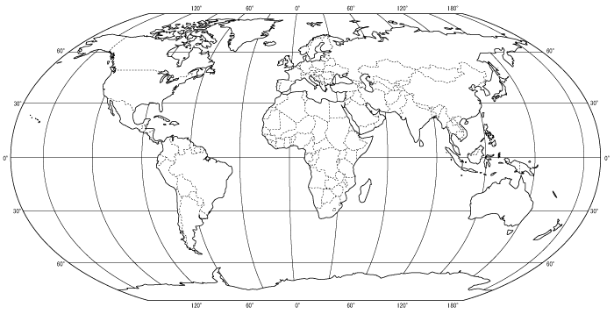

14. Define the following economic systems:
Market Economy: Traditional economy:

Command Economy: Mixed economy:

15. Why is the family the key feature of a culture’s social organization?

16. Define the following types of government:
Republic:

Democracy:

Dictatorship:

AFRICA
Geography
17. What are the 4 types of Climate Zones found in Africa?

18. Desertification is caused by ________________________________________________________.

19. This is the longest river in Africa which flows through a desert and allows for fertile farmland and transportation in portions of Egypt and Sudan.

20. Africa has many resources, name 3. In ONE word describe how these resources are distributed.

History
21. Slave Trade:
When:

Why did the demand for slaves increase:

Effects of the slave trade: List at least 3!

What is the Diaspora in the relation to the African Slave Trade?

22. Define Imperialism:

23. What 3 reasons did the Europeans want to colonize Africa?

Positive effects of Imperialism:

Negative Effects of Imperialism:

24. What are the three things that made it possible for Europeans to take over African nations?

25. What are three areas where we see hints of colonialism in Africa?

26. ________________________________________were the first Europeans in South Africa. Soon the ____________________________ settled and came after ___________________ were found in the Transvaal.

27. What are 4 characteristics of apartheid laws for non-whites?

African Culture/ Modern Issues
28. Describe the traditional role of women in Africa.

29. How do some Africans feel about the west (think modernization)?

30. True or False Cities are rapidly decreasing because young people are moving to the cities to and need jobs, housing and education.

31. What are 3 issues facing Africa today?

32. What event started the Rwandan genocide in 1994?

33. Why was there tension between the Hutus and Tutsis?

34. Who were the Interhamwe?

35. ______________________________ of _______________________________ was in power for over 40 years and killed by rebels in 2011 as part of the Arab Spring.

36. Explain conflict diamonds and what's going on.

37. What are 3 environmental concerns in Africa?

38. What is the world’s newest country?

39. What are child soldiers? Where are we seeing children being employed by the government?

40. Define elite.

41. Define consensus.

42. Define patriarchy and patrilineal.

43. Define matriarchy and matrilineal.

44. _________________________ links the Mediterranean Sea with the Red Sea.

45. _________________________ largest desert in the world.

46.________________________________ energy produced by moving waters

47. _______________________________ prolonged periods of little or no rainfall is common

48. _______________________________This man was responsible for slave labor in his mines and rubber plantations in the Congo. He was famous for cutting off body parts of miners who did not cooperate.

49._________________________ the systematic killing of an ethnic group

50. _________________________________ the separate development of the races

51. _________________________ South African leader was jailed for 27 years for speaking out against the government. He became the 1st black president of South Africa.

52. _________________________ this man also spoke out against apartheid. He founded the Black Consciousness movement. He was arrested and beaten in jail and subsequently died from his injuries.

53. ________________________ this man was the white president of South Africa who ended apartheid.

54. What was the Berlin Conference? Who was there? What happened?

Middle East Vocab/ Who Am I?

55. ________________________ is the most important natural resource in the Middle East but also the scarcest resource.

56. ________________________ is an important economic resource in the Middle East but is not evenly distributed amongst the nations.

57. ________________________ has determined where people live in the Middle East.

58. __________________________________This group of people’s name translates to “the people of the tent”. They are a fascinating group that travels the desert following their herds- typically by camel, but now many own trucks. They are also known for their amazing weaving.

History of the Middle East

59. What were the expectations of women in village life? What are women’s quarters? (Patterns of life)

60. Define Zionism.

61. In ONE word, what is the basis of the Arab-Israeli conflict?

62. Israel was created within what country? And where did those citizens (of the original country) have to move to?

63. List the 3 occupied territories.

64. What happened at the Oslo Accords?

65. T/F: The Balfour Declaration was a British document that supported a Jewish homeland in Palestine.

Middle Eastern Religions
66. What are the five pillars? (In words that you understand)

67. What is the difference between Sunnis and Shias? What caused the split?

68. What city is holy to all three religions?

69. Why are the 10 commandments and the Five Pillars of Islam similar?

70. T/F Judaism, Christianity and Islam share no historical traditions.

71. Why do some women veil themselves?

Know the 3 major religions of the Middle East ( notes, charts/ graphic organizers)

Who/What am I?

72. _______________________________ largest ethnic group in the Middle East

73. _______________________________ this man listened to the word of the angel Gabriel and is the considered the greatest prophet in the Islamic religion

74. Why is the Middle East attractive to other countries around the world today?

75. What is the Arab Spring? What helped “spread” the movement around the Middle East?

76. What sparked the Arab Spring and where was this?

77. Put the countries in order when they occurred during when their “Arab Spring”. (Yemen, Libya, Egypt, Syria)

78. What are two rights women in Saudi Arabia are not allowed?

79. What is Shariah? How do groups like Al-Qaeda view the United States?

80. What is ISIS? What is the goal of this group?

Map-
Be able to place the following on a map…
1. Mount Kilimanjaro
2. Atlas Mountains
3. Nile River
4. Egypt
5. Libya
6. Rwanda
7. Sudan
8. South Sudan
9. South Africa
10. Sahara Desert
11. Kalahari Desert
12. Arabian Peninsula
13. Israel
15. Iran
16. Iraq
17. Syria
18. Kuwait
19. Tigris River
20. Euphrates River
21. Suez Canal
22. Red Sea
23. Persian Gulf

