Name:__________________________________________ Date:_____________________
Three Gorges Dam Controversy
Common Core Objectives:
R.H.9-10.2: Determine the central ideas or information of a primary or secondary source; provide an accurate summary of how key events or ideas develop over the course of the text.
R.H.9-10.7: Integration of Knowledge and Ideas: Integrate quantitative or technical analysis (e.g., charts, research data) with qualitative analysis in print or digital text.

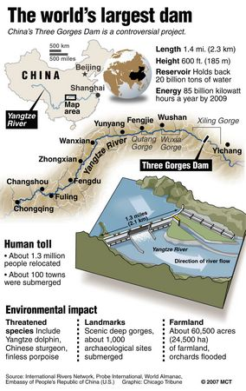
Directions: Read the article, and look at the attached visuals. Then, complete the graphic organizers that follow.

More than 1.2 million people were displaced as the waters in the monumental [Three Gorges Dam on the Yangtze River], which started accumulating 10 years ago on Saturday, submerged scores of towns and communities, and thousands of poorly compensated migrants remain mired [stuck] in poverty.

But China's growing thirst for energy means that the Three Gorges -- which generates roughly as much electricity as a dozen commercial nuclear reactors and cost $37 billion to construct -- is a model for 50 large dams to be built in the country, according to its current five-year plan.

Those [dams] will crank out more than the current hydropower capacity of the US, putting China -- already the world's largest hydropower consumer -- on the way to providing 15 percent of its energy from renewable sources by 2020.

China's state-run media has praised the Three Gorges dam for generating over 88.2 terawatt hours (TWh) of electricity last year -- more than France's entire yearly renewable energy output, and exceeding the project's original goal.

The barrier's huge reservoir has also been hailed for lessening floods which have for millennia plagued the mighty Yangtze river as it cuts through central China, claiming thousands of lives as recently as 1998.

As flood waters upstream from the dam reached a peak last year, television images showed thundering torrents of water spraying from the structure -- as it held the bulk of the deluge in its huge reservoir.

But the dam has also been blamed for amplifying changes in weather patterns which in 2011 produced the Yangtze's largest drought in half a century, while heavy rains have continued to flood cities downstream, killing hundreds.

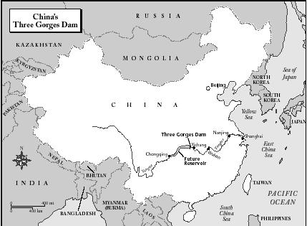
As dam officials sacrificed energy generation to release water to combat the drought, China's State Council, or cabinet, made a rare admission that the Three Gorges faced "urgent problems", including the relocation of migrants and ecological damage.

One migrant whose home was submerged by the dam said he refused to accept government compensation money, claiming it was too low and that land assigned to migrants had been sold by local officials to build a shopping mall.

"The land they compensated us with was scattered in the areas across the city that no one else wants. We can't run a business there. Of course we can't sign the agreement," Luo Xianwen, 69, told AFP.

The much-touted powers of the dam to boost shipping on the Yangtze -- turning it into a superhighway for large tankers which would for the first time be able to reach the inland megacity of Chongqing -- have proved limited.

Ships can wait for up to a week before being allowed to pass through the dam's choked locks, which can in itself take seven hours, shifting freight to newly built roads and railways nearby, reports say.

Fish stocks in the Yangtze have declined rapidly since the dam was built and fecal substances that can cause death have been detected in the reservoir, scientists have found -- while mountains of trash have accumulated in the water.

But despite the problems, the Three Gorges will be joined by a wave of new hydropower projects over the next decade -- mostly spread across China's mountainous and earthquake prone southwest.
The Xiluodu dam, the largest in the world in terms of the amount of water that it can release at any given time, is scheduled to begin producing electricity in June.

China's environment ministry approved the Shuangjingkou dam in a Tibetan area of southwestern Sichuan province earlier this month, the world's tallest at 314 meters high.

The ambitious plans have left some in China's growing environmental movement feeling powerless.

"We continue to oppose the hydropower plans... they will create all the same problems with migration and the environment," said Dai Qing, who spent time in prison for her opposition to the Three Gorges dam.

"Industry and local governments support these hydropower projects, because they'll profit from them," she added.

"And they will be built no matter what local people say."

Sources:
“A Decade on, Controversy Still Surrounds China’s Three Gorges Dam,” AFP, August 26, 2013, accessed January 26, 2016, http://www.sbs.com.au/news/article/2013/05/31/decade-controversy-still-surrounds-chinas-three-gorges-dam

"Map of the Area Affected by the Three Gorges Dam in China." History Behind the Headlines: The Origins of Conflicts Worldwide. Ed. Sonia G. Benson, Nancy Matuszak, and Meghan Appel O'Meara. Vol. 4. Detroit: Gale, 2002. 64.Global Issues In Context. Web. 26 Jan. 2016.

"The World's Largest Dam." MCT Graphic Services. 2007. Global Issues In Context. Web. 26 Jan. 2016.
Name:__________________________________________________ Date:____________________________
Three Gorges Dam Controversy
Directions: Complete the graphic organizer below, demonstrating the positive and negative effects of the Three Gorges Dam.
Positive Effects of the Three Gorges Dam | Negative Effects of the Three Gorges Dam
1.  2.  3. | 1.  2.  3.

Next, categorize the positive and negative effects (and any others not in the chart above) into social, economic, and environmental effects…

Social Effects | Economic Effects | Environmental Effects

Now, complete the graphic organizer regarding Human-Environment Interaction and the Three Gorges Dam.
Depend  (What do humans need the environment for?) | Adapt  (How do humans adjust to the environment?) | Change  (How do humans alter the environment? Are those alterations positive or negative?)

Finally, write a 5-8 sentence summary regarding the controversy surrounding the Three Gorges Dam.

_________________________________________________________________________________________________________________________________________________________________________________________________________________________________________________________________________________________________________________________________________________________________________________________________________________________________________________________________________________________________________________________________________________________________________________________________________________________________________________________________________________________
____________________________________________________________________________________________________________________________________________________________________________________________________________________________________________________________________________________________________________________________________________________________________________________________
____________________________________________________________________________________________________________________________________________________________________________________________________________________________________________________________________________________________________________________________________________________________________________________________

