Name:______________________________________________________Date: _____________Period: _______________
LITERACY GUIDE – SOUTH ASIA
Textbook Chapters you will use:
Chapter 7: Section 1 (pages 161-165) – Section 2 (pages 165-170) – Section 3 (pages 170-174)
Chapter 8: Section 1 (pages 177-182) – Section 3 (pages 189-193) – Section 4 (pages 193-198)
Chapter 9: Section 1 (pages 201-204) – Section 4 (pages 214-216) – Section 5 (pages217-220)
Chapter 10: Section 1(pages 223-226) – Section 3 (pages 232-236)

FOCUS QUESTIONS:
- I will be able to describe the impact of South Asia’s geography on its people.
- I will be able to describe the impact the Aryans had on India.
- I will be able to compare and contrast Hinduism & Buddhism.
- I will be able to explain how the formation of the caste system influenced Indian society.

PRE-READING:
- PREDICT: How has geographic features affected the peoples of the South Asia? Give two specific predictions.

- PREDICT: Why is our knowledge of the Indus Valley civilization is limited?

- PREDICT: Which religions trace their origins to the South Asia?

- PREDICT: What is the structure of the caste system? How did the caste system impact people’s daily lives?

VOCABULARY: Fill in the chart (identify)
Vocabulary Term | Definition (In your own words) | Illustration / Example
Chapter 7 Section 1 The Shape of the Land pages 161 - 165
Subcontinent

Chapter 7 Section 2 Climate and Resources pages 165 - 170
Monsoon

Rain Shadow

Dialect

Chapter 7 Section 3 Early Civilizations of India pages 170 - 174
Cities of
Harrappa &
Mohenjo-daro

decipher

Aryans

Vedas

Sanskrit

Rajahs

Varna

Caste

Chapter 8 Section 1 Religious Traditions pages 177 - 182
Hinduism

Vedas & Upanishads

brahman

Brahma, Vishnu & Siva

Sects

Atman

Reincarnation

Karma

Dharma

Buddhism

Nirvana

Four Noble Truths

Noble Eightfold Path

Chapter 8 Section 3 Patterns of Life pages 189 - 193
Caste System

Joint Family

Purdah

Chapter 8 Section 4 India Under British Rule pages 193 - 198
Monopoly

Sepoys
(Sepoy Rebellion)

Nationalism

Chapter 9 Section 1 Freedom – and Partition pages 201 - 204
Amritsar Massacre

Mohandas Gandhi

Satyagraha

Civil disobedience

Salt March

Muhammad Ali Jinnah

Muslim League

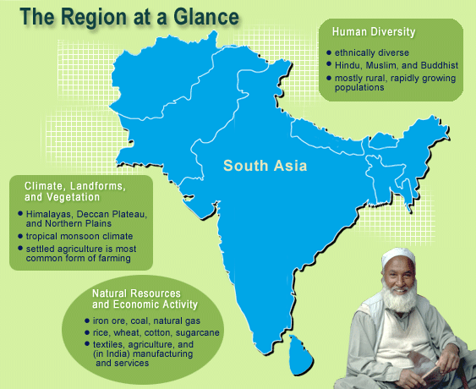
South Asia Geography and Climate Notes

South Asia
South Asia—which includes the nations of India, Pakistan, Afghanistan, Bangladesh, Bhutan, Sri Lanka, the Maldives, and Nepal—is one of the most densely populated regions on Earth, harboring one-fourth of the world's population, or more than 1.6 billion people. As a consequence, the area faces challenges with regard to humanity's interaction with nature.
Landforms
South Asia is bounded on the north by the Hindu Kush and Himalaya Mountains. The Himalaya Mountains (which contain Mt. Everest and are the tallest mountains in the world), as well as the Zanskar and Nanga Parbat ranges of Kashmir, act as dramatic barriers between South Asia and its northern neighbors. South of these mountains lies the Deccan Plateau. This occupies nearly half of South Asia and contains millions of farms that grow cotton, wheat and rice.
Other mountains in South Asia include the Hindu Kush Mountains which act as a border between Pakistan and Afghanistan. They are very rugged and even the name “kush” means death. Although the mountains form a barrier, they can be crossed. In the west, several passes cut through the mountains, making movement possible between the Indian subcontinent and other parts of Asia. Among the best known is the Khyber Pass through the Hindu Kush. For thousands of years, traders and invaders have made their way through mountain passes and descended into India.

Sandwiched between the Himalayas and the Deccan Plateau is the Indo-Gangetic Plain, a lush region bordered by the Ganges and Indus (“river”) rivers. Stretching across the most fertile regions of Pakistan, India, and Bangladesh, the densely populated Indo-Gangetic Plain is the center of agricultural output throughout South Asia. The nation's major waterways are the Ganges River, which runs east from the Himalayas into the Bay of Bengal; the Brahmaputra River, which courses through eastern India and meets the Ganges in Bangladesh; and the Indus River, which flows along the northwestern border with Pakistan toward the Arabian Sea.
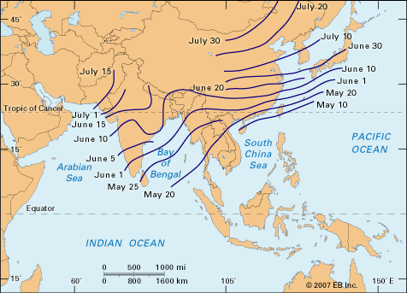
Not to be forgotten are the many deserts of the region, including the Thar and Rajasthani deserts, as well as the islands of the Indian Ocean, particularly the Maldives, Sri Lanka, and the Andaman and Nicobar Islands. Predominantly tropical, these islands are often densely forested, and, like the rest of South Asia, are home to an abundance of animal life.
Climate
The climate of South Asia, like its landscape and population, is diverse. The overarching climate of the region is monsoonal, with upward of 90% of the year's precipitation coming in the summer and autumn months. Along the coastal regions, monsoons (seasonal winds) can wreak havoc when they arrive, with violent winds and flooding rains; while in the deserts, the monsoons are greeted with joy, as they bring precious water to sustain life in an otherwise arid environment. The months between June and September are the wettest for Pakistan and the western coast of India, while the eastern coast of India and its neighbors, including Bangladesh, experience their wettest months between September and December. In the Indian Ocean, typhoons can develop during the monsoon season, increasing rainfall substantially and bringing the potential for extreme destruction. One of history's most devastating tropical cyclones, a November 1970 typhoon, struck Bangladesh and killed more than 500,000.
Monsoon Winds
In the wintertime, the Himalayas receive large amounts of snow. More temperate inland and coastal regions of South Asia, however, generally enjoy dry, pleasant weather during the winter months. Rain may fall in tropical areas, especially in Bangladesh, but not nearly at the rate that it falls during the monsoon season. In most parts of South Asia outside of the Himalayan region, winter is considered the most pleasant season of the year and is the peak time for tourism and travel.

People
South Asia enjoys tremendous human diversity, with many ethnic and religious groups calling the region home. More than 1,000 ethnic groups live in the eight South Asian nations of India, Pakistan, Afghanistan, Bangladesh, Bhutan, Sri Lanka, the Maldives, and Nepal, and several hundred languages and dialects are spoken throughout the region. However, there are dominant languages—Hindi, Urdu, and Bengali permeate popular culture in Pakistan, Bangladesh, and India, while ancient Sanskrit and Qur'anic Arabic remain sacred languages for the hundreds of millions of Hindus and Muslims in the region.
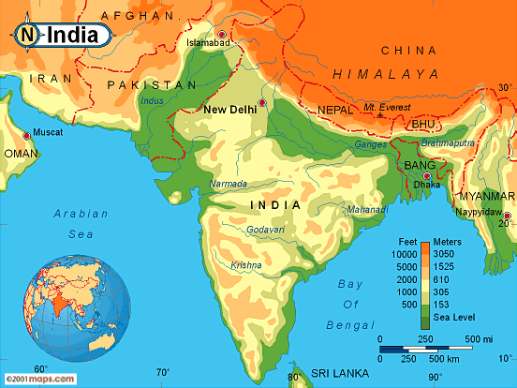
Natural Resources and Agriculture
The diverse landscape of South Asia is famously rich in natural resources, including hardwoods, coastal fish reserves, salts, medicinal plants, and indigenous cereals. Moreover, South Asia is blessed with climates that are ideal for producing large amounts of agricultural bounty—a necessity in such a densely populated part of the world. In many of the wettest regions—including Assam in India and Bangladesh—shifting, or slash-and-burn, agriculture is practiced, whereby farmers clear patches of forest using fire, then sow their crops in the burned-out areas. Rice, corn, and many vegetables thrive under postfire conditions, as does cotton, a vital crop for clothing production.
Settled agriculture (typical farming), however, is the most common form of farming practiced in South Asia and is particularly successful in well-irrigated and well-drained regions, most notably in central India. Settled farming does not only allow for the production of food for subsistence, but also for extensive plantations of export crops, including tea, cotton, sugarcane, and rice. Although most agriculture in India is still very labor-intensive, with people and animals doing the bulk of the work, larger concerns have introduced high-technology equipment, resulting in far higher crop yields than possible with traditional farming methods. However, as the already bursting population grows, issues of sustainability continue to plague the region, and resource sustainability is likely to be the most pressing issue facing South Asia and its people in the 21st century.

Sources:
India: Topography. Map/Still. Encyclopedia Britannica. Web. 15 Jan. 2013. <http://www.school.eb.com/comptons/art-137842>.
Indian Monsoon: Average Dates of Summer Monsoon Across Asia. Map/Still. Encyclopedia Britannica. Web. 15 Jan. 2013. <http://www.school.eb.com/comptons/art-117507>.
"Region at a Glance: South Asia (illustration)." Image. World Geography: Understanding a Changing World. ABC-CLIO, 2013. Web. 15 Jan. 2013.
Stockdale, Nancy. "South Asia." World Geography: Understanding a Changing World. ABC-CLIO, 2015. Web. 15 Dec. 2015.
South Asia Geography and Climate Handout 3 Column Notes
Directions: Using the South Asia Geography and Climate handout, take notes by turning the section heading into a question, writing out bold terms and their definitions in the center and taking notes in the far right column.
Common Core Objective: R.H.9-10.2: Determine the central ideas or information of a primary or secondary source; provide an accurate summary of how key events or ideas develop over the course of the text.
Section Headings | Bold Words | Details
What is South Asia? | None | - India, Pakistan, Afghanistan and other countries  - More than 1.6 billion people  - 25% of world’s population
Section #2: |  | 1.  2.  3.
Section #3: |  | 1.  2.  3.
Section #4: |  | 1.  2.  3.
Section #5: |  | 1.  2.  3.

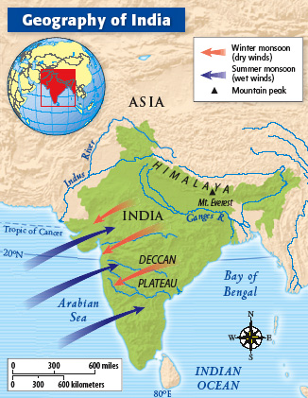
MAP STUDY: Monsoons in South Asia
The monsoons profoundly affect the climate in South Asia. They determine the duration of this huge region’s two seasons – summer and winter.

1. MOVEMENT: (a) Where does the summer monsoon originate? (b) In which directions does it move?

2. MOVEMENT: (a) Where does the winter monsoon originate? (b) In which directions does it move?

3. FORECASTING: (a) Which parts of South Asia do you think receive the largest amount of rainfall? (b) In which season does this rainfall occur?

4. HEI: Give two ways in which the people of India have either adapted to, depended on or changed because of the monsoons.

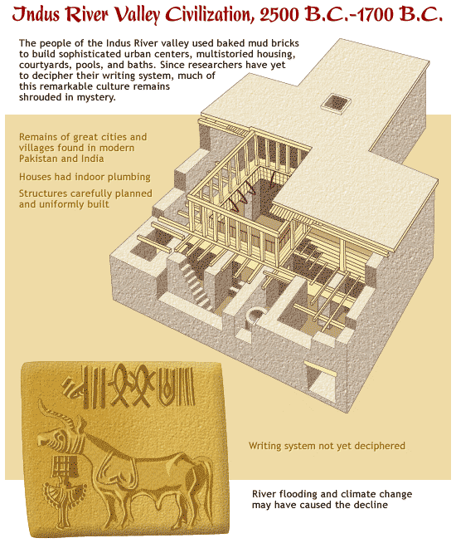
Indus River Valley Civilization
The cities of Harappa and Mohenjo-Daro, in present-day Pakistan, were the most important.
Each city was carefully laid out, with straight streets that formed a checkerboard pattern. A walled fortress protected the city, and special warehouses held food supplies. The cities had separate districts for homes and for public buildings. Some building had elaborate bathing facilities and drains that linked them to a city sewer system.
This level of urban planning suggests that the government was well organized. It was able to set and enforce building codes. Throughout the Indus Valley, for example, the bricks used for building were all the same size.

1. What do the cities of Harappa and Mohenjo-Daro reveal about the Indus Valley civilization?

2. Why is our knowledge of Indus Valley civilization limited?

THE ARRIVAL OF THE ARYANS
PARAPHRASING YOUR IDEAS: Using complete sentences, students should paraphrase the excerpts from the text.
Excerpt from text | Paraphrase
Merchants of the Indus Valley civilization traded with the peoples of the Middle East. Either overland or by sea, traders carried goods from Harappa to Sumer, an early civilization of the Middle East. Perhaps Harappan merchants exported cotton to the Middle East. Through trade, ideas, too, passed back and forth.

The Aryans swept into India through the high passes of the Hindu Kush Mountains. They came from the region of the Caucasus Mountains. As they traveled, they came in contact with the peoples of the Middle East. From them, the Aryans learned how to make iron tools and weapons.

Much of what we know about the Aryans comes from oral religious traditions, known as the Vedas. The Vedas include hymns, prayers, and rituals used in religious ceremonies. They were composed between 1500 B.C. and 1000 B.C. Today, the Vedas are still part of Indian religious life. People site Vedic hymns and prayers on many special occasions, such as weddings and funerals.

As the Aryans moved across the northern plains, they settled into villages. The pattern of village life that developed over centuries continues to influence India today. The Aryans were both farmers and herders. They place great value on cattle. People measured wealth in terms of cattle. The Vedas compare the Earth to a cow. Rain is like the cow’s milk, and the sun is its calf.

The Aryans divided people into four classes, called varna. At the top of society were Brahmans, or priests. Next came Kshatriyas, or warriors. The third class, Vaisyas, were landowners, merchants, and herders. At the bottom of society were the Sudras, servants and peasants who waited on others.

Chapter 8 Section 1 Religious Traditions (pages 177-182) Venn Diagram

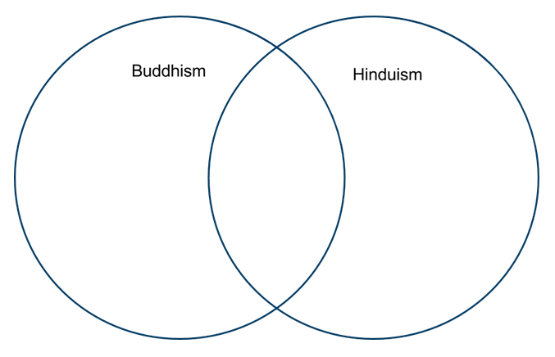

Summary:
__________________________________________________________________________________________________________________________________________________________________________________________________________________________________________________________________________________________________________________________________________________________________________________________________________________________________________________________________________________________________________________________________________________________________________________________________________________________________________________________________________________________________________________________________________________________________________________________________

Chapter 8 Section 3 Patterns of Life (pages 189-193) 3 Column Notes
Directions: Using the textbook, read Chapter 8 Section 3 Patterns of Life. After you read take notes by turning the blue section heading into a question, writing out bold terms and their definitions in the center and taking notes in the far right column.
Section Headings | Bold Words | Details
Section #1 |  | 1.  2.  3.  4.
Section #2: |  | 1.  2.  3.  4.
Section #3: |  | 1.  2.  3.  4.
Section #4: |  | 1.  2.  3.  4.
Section #5: |  | 1.  2.  3.  4.

Summary:
__________________________________________________________________________________________________________________________________________________________________________________________________________________________________________________________________________________________________________________________________________________________________________________________________________________________________________________________________________________________________________________________________________________________________________________________________________________________________________________________________________________________________________________________________________________________________________________________________

