Problems in America Mini-Q
Focus Question: Describe two problems seen in America today.

Part 1: Reading and Annotating the Document – H.A.P.P.Y.
1-Read the documents carefully, answering the questions as you go.
Document #1
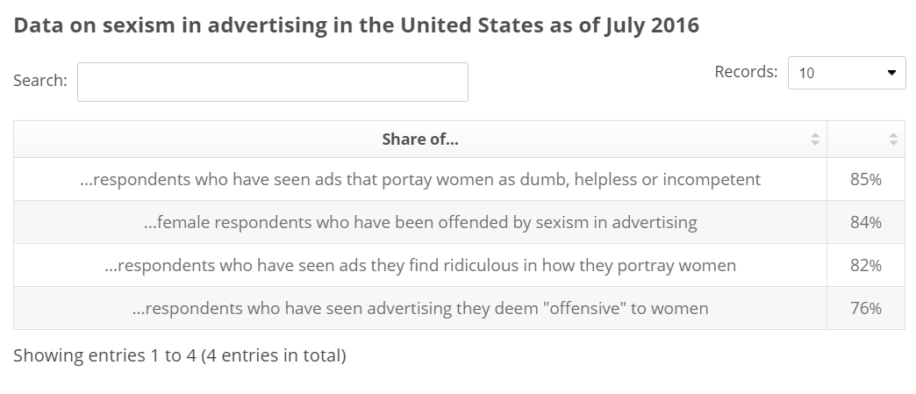
Source: AAAA. "Data on Sexism in Advertising in The United States as of July 2016." Statista - The Statistics Portal, Statista, www.statista.com/statistics/628166/sexism-advertising-usa/.

Document: Date:  Source/Author: |  | Y: whY does this help you answer the question?
Historical Context

Audience

Purpose

Point of View

Which component(s) best help you answer the question? Explain WHY.

Document #2
Recently, young fraternity members at the University of Oklahoma were caught on video singing a chant that copiously [abundantly] used the N-word, proclaiming that there would never be one in their fraternity. Two students were expelled, and we were treated to the requisite [required] white American morality tale of shock, disavowal and denouncement [declaration of being morally wrong].

The problem is that these incidents happen every year. In fall 2013, a white sorority at the University of Alabama rejected two pledges of color seemingly solely on the basis of race.

Moreover each year, we hear stories of fraternities and sororities and other campus groups throwing race-themed parties that traffic in stereotypes about African-Americans and Latinos.

The shock and surprise from white Americans about these continued incidents baffle me. These clear racist and racially-tinged occurrences happen with … regularity. The question is why we think the problem of racism is an evolutionary problem rather than an ideological [philosophical] one. We treat racism as though it is the contained characteristic of a specific species of human beings known as racists, that lived in a prior era of American history, but have now nearly become extinct. We keep missing that racism is ideological and institutional, rather than merely individual.

Source: Brittany Cooper, “We Treat Racism Like it’s Going Extinct. It’s Not.,” PBS, March 23, 2015, http://www.pbs.org/newshour/updates/treat-racism-like-going-extinct/

Document: Date:  Source/Author: |  | Y: whY does this help you answer the question?
Historical Context

Audience

Purpose

Point of View

Which component(s) best help you answer the question? Explain WHY.

Document #3
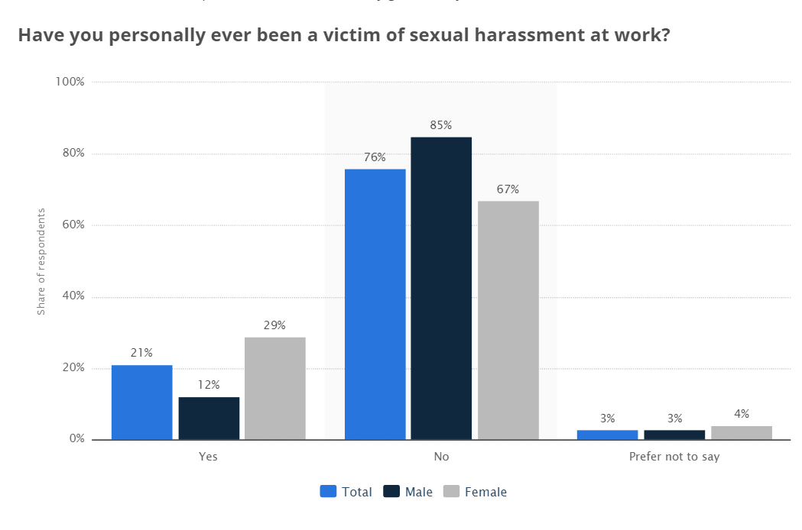
Source: "Have You Personally Ever Been a Victim of Sexual Harassment at Work?." Statista - The Statistics Portal, Statista, www.statista.com/statistics/644351/sexual-harassment-victims-in-the-us-workplaces-by-gender-july-2016/, Accessed 22 May 2017
Document: Date:  Source/Author: |  | Y: whY does this help you answer the question?
Historical Context

Audience

Purpose

Point of View

Which component(s) best help you answer the question? Explain WHY.

Document #4
Baltimore Orioles outfielder Adam Jones called the racist comments directed toward him at Fenway Park earlier this season "disgusting" in a Players' Tribune exclusive on Friday.

Jones' piece, which was accompanied by a video, was published after he was the subject of racist taunts and actions from fans in Boston at a game earlier this month.

"Well, it's 2017, and some people are still just stupid," he said. "I've heard plenty of stuff on a baseball field over the years. You expect trash talk from fans. Sometimes you even enjoy it. But to be out there playing the game you love, and to hear somebody call you the N-word? To have peanuts thrown at you, like you're not even a human being? It's disgusting."

Source: Alec Nathan, “Adam Jones Comments on Dealing with Racism in Players’ Tribune Exclusive,” Bleacher Report, May 19, 2017, http://bleacherreport.com/articles/2710598-adam-jones-comments-on-dealing-with-racism-in-players-tribune-exclusive

Document: Date:  Source/Author: |  | Y: whY does this help you answer the question?
Historical Context

Audience

Purpose

Point of View

Which component(s) best help you answer the question? Explain WHY.

Part 2: Brainstorm Ideas & Categorize Documents

Focus Question: Describe two problems seen in America today.

Directions:
STEP 1: Answer the focus question based on your analysis of the documents.
STEP 2: Categorize the documents based on how they help you answer the question.

Part 3: Formulating a Thesis, Based on the Evidence

Focus Question: Describe two problems seen in America today.

Directions: Pick 1 of the following options. (You can earn up to a “Proficient” only, if you use the claim starter).

Claim #1
Two problems seen in America today include [identify and briefly detail at least 2 reasons] ____________________________________________________________________________________________________________________________________________________________________________________________________________________________________________________________________________________________________________________________________

Claim #2: Make your own….
________________________________________________________________________________________________________________________________________________________________________________________________________________________________________________________________________________________________________________________________________________________________________________________________________________________________________________________________________________________________________________________________________________________________________________________________________________________________________________________________________

Not Present (0 pts.) | Novice (1 pt.) | Proficient (2 pts.) | Expert (3 pts.)
Thesis  (0-3 pts.) | Contains an unclear or emerging claim that suggests a vague position. | Introduces a claim that is clearly arguable and takes an identifiable position on an issue. | Introduces a precise claim that is clearly arguable and takes an identifiable position on the issue. The claim statement includes not only a list of main points, but a concise preview of the reasoning behind the claim.

