Pakistan 101 Name: _________________________________________
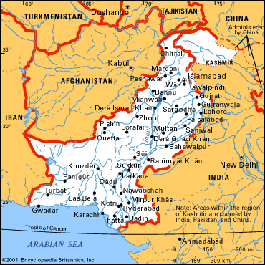

The South Asian country of Pakistan was the site of one of the world's oldest civilizations. Nevertheless, it is a young country. In 1947 the colony called British India gained independence and was divided into two countries: Pakistan and India. Pakistan was meant to be a homeland for the colony's Muslims. The capital of Pakistan is Islamabad.

1. What year did was India divided into India and Pakistan? Pakistan was to be a homeland for whom?

2. What is the capital of Pakistan?
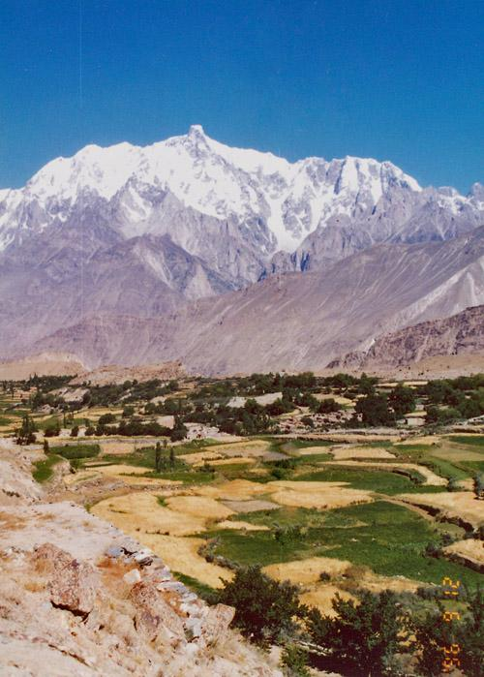
Hunsa Valley- Plains

Geography: Pakistan is bounded on the west by Iran, on the north by Afghanistan, on the northeast by China, on the east and southeast by India, and on the south by the Arabian Sea. It covers an area of 307,374 square miles. This figure does not include the region of Kashmir, which is disputed territory between Pakistan and India. Pakistan has three major natural regions. The Himalayas and the Karakoram Range in the northern part of the country include some of the highest and most rugged mountains in the world. Among them is K2, the world's second-tallest peak at 28,251 feet. The Balochistan plateau of western Pakistan is a very dry region of deserts, salt lakes, and a narrow coastal plain. In the east are the flat, fertile plains of the Indus River. The majority of the country's people live in this region. Pakistan has hot summers and cool or cold winters. Summer temperatures can climb higher than 120° F. It is generally very dry, but seasonal winds called monsoons bring rain from June through September.
3. What countries border Pakistan?

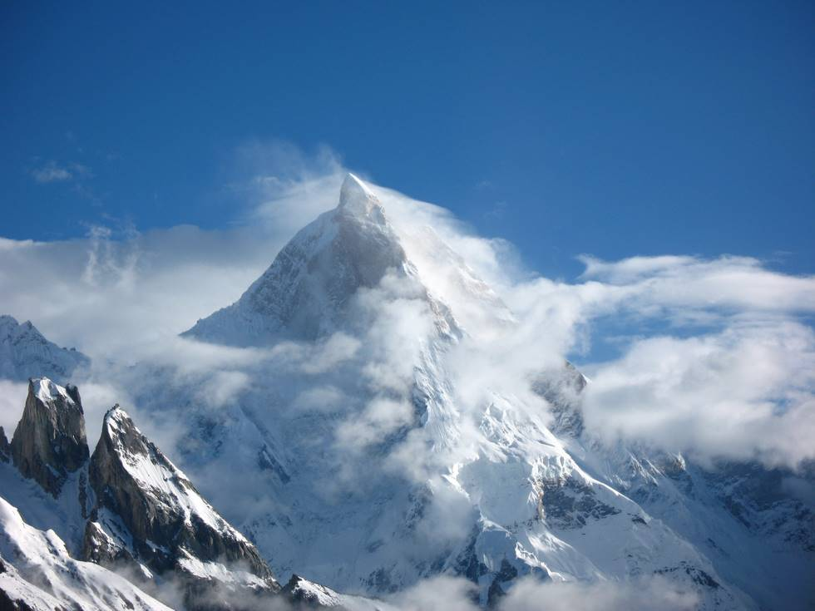
K2

4. What is K2? Elevation?

5. Describe the topography of Pakistan.

6. Describe the weather of Pakistan.

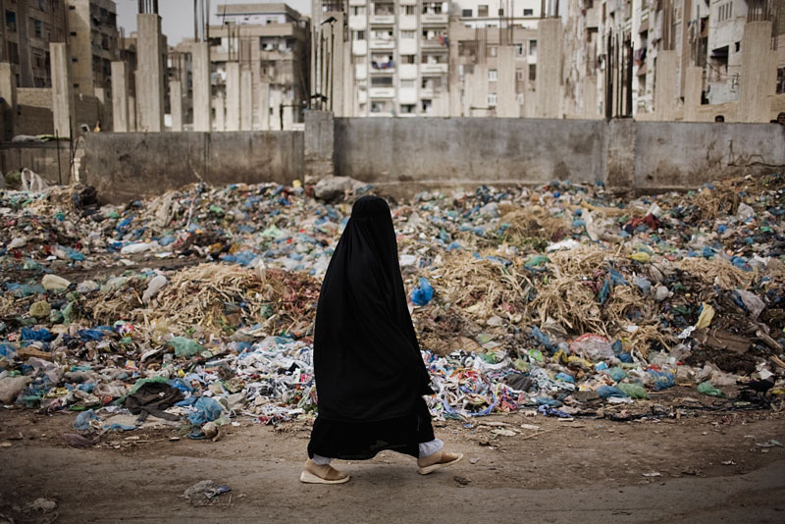
People and culture: The people of Pakistan are a racial mixture of various groups who have lived in the region over thousands of years. The population includes five major ethnic groups: the Punjabis, the Pashtuns, the Sindhis, the Balochis, and the muhajirs. Punjabis make up about half of the population, and their language is the most commonly spoken. Almost everyone in Pakistan practices the religion of Islam. When Pakistan was separated from the Hindu state of India in 1947, millions of Muslims left India to settle in Pakistan. These people and their descendants are the muhajirs.
Slum in Lahore

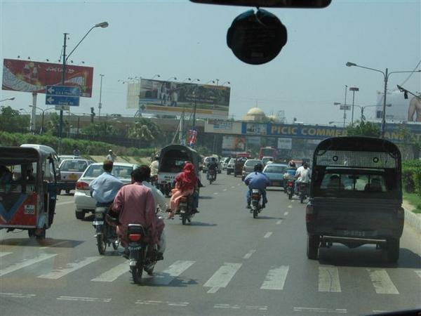
They speak Urdu, which is the country's official language. Most educated Punjabis speak Urdu as well. The majority of the people of Pakistan live in rural areas, but the cities have grown rapidly. The largest cities are Karachi and Lahore. Located on the Arabian Sea coast, Karachi is Pakistan's main port and center of commerce and industry. It was also the national capital until 1959, when Islamabad was chosen as the site of the new capital. Lahore, located near the border with India, is an educational center.

7. What are the five major ethnic groups of Pakistan?

8. What is the main religion in Pakistan?

9. What is the country’s official language?

10. What are the two largest cities in Pakistan?

Traffic in Karachi

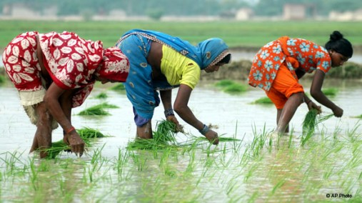
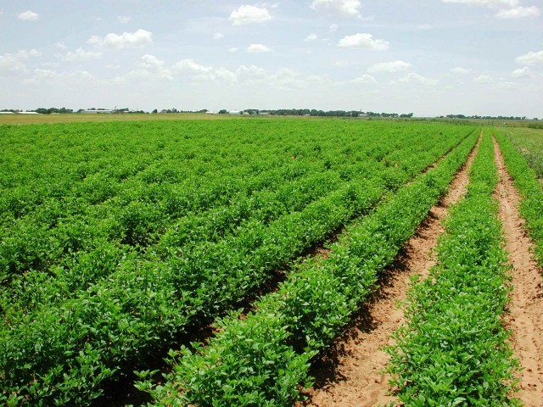
Economy: Before Pakistan became independent in 1947, the economy was mostly agricultural. Since then the economy has become more diverse. Nevertheless, agriculture still employs more Pakistanis than any other activity. The main crops are wheat, rice, sugarcane, and cotton. Rice is exported, but cotton is the most important cash crop. Goats, sheep, cattle, and water buffalo are kept as livestock. Agriculture provides raw materials for some of Pakistan's most important industries. Textiles, especially made of cotton, and clothing are the country's leading exports. Livestock are a source of wool for making carpets and hides and skins for producing leather goods. Other manufacturing industries in Pakistan produce chemical fertilizers and processed foods. Mining is only a small part of Pakistan's economy. The country has huge supplies of limestone, however, which is used to make cement. Coal mining is one of the country's oldest industries, but the quality of the coal is poor. Pakistan also has small quantities of oil and some very large natural gas fields.
Rice farming in Pakistan

11. What industry employs more Pakistanis than any other? Why?

12. What is the country’s leading export?

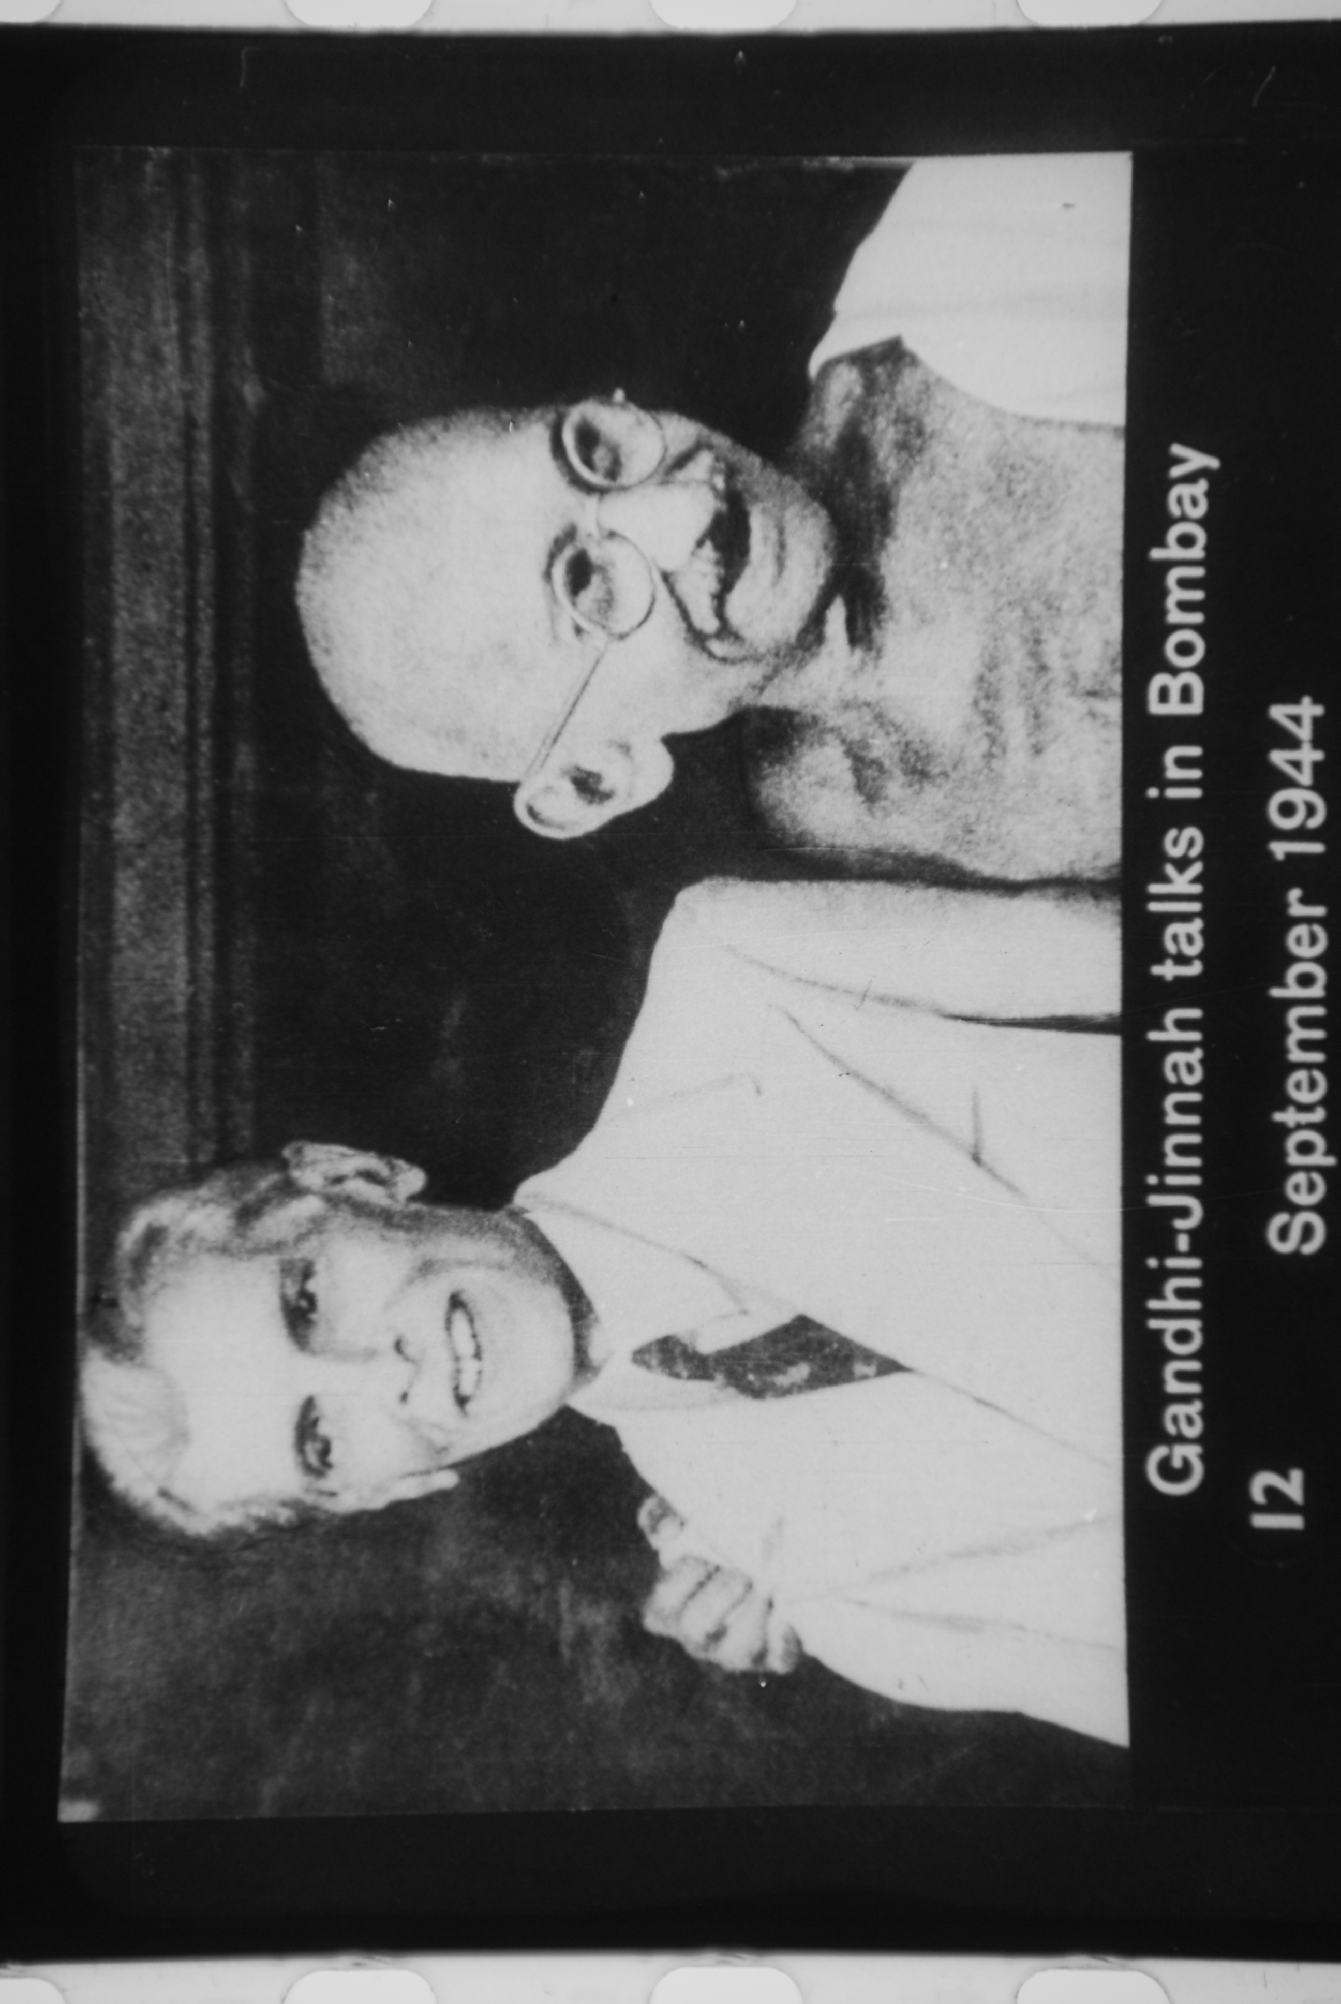

History: Pakistan and India share a common early history because they were united until 1947. From the 1850s until that date the British government ruled them together as a colony called British India. In the 20th century the people of the colony began to seek independence from Britain. As the British began to consider granting independence, Muslims in India feared that the Hindu majority would mistreat them in the new country. By 1940 the Muslims, led by Mohammed Ali Jinnah, demanded the creation of a separate Muslim state. Pakistan was made up of two regions, West and East Pakistan, that were separated by more than 1,000 miles (1,600 kilometers) of Indian territory. After the British left, many Muslims fled India for Pakistan and many Hindus left Pakistan for India. Many people from both communities were massacred during this period.
13. Who was the Indian leader who called for a separate Muslim state?

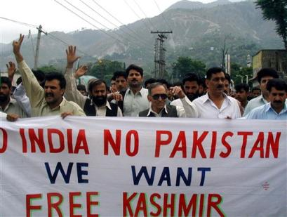

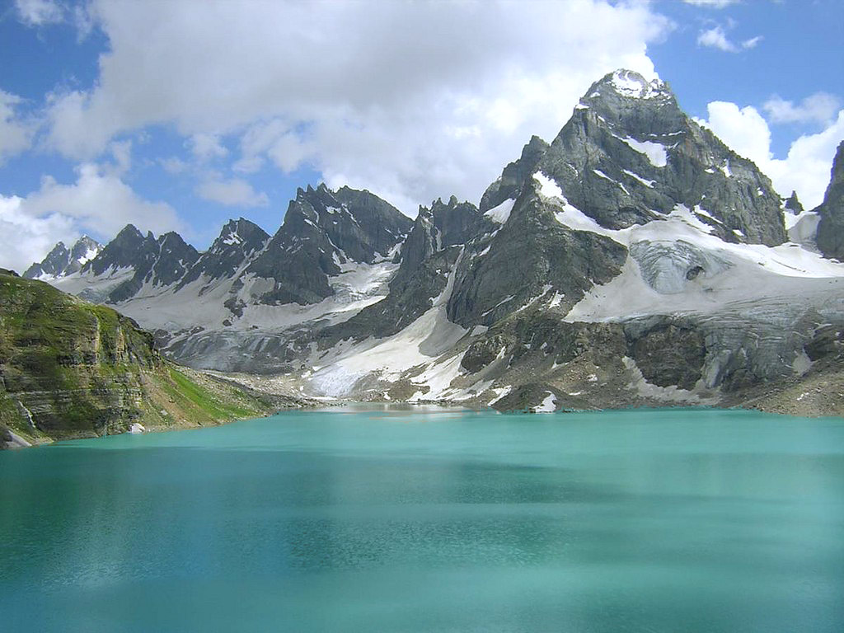
Armed conflicts: After the separation, the territory between Pakistan and India known as Kashmir remained disputed. Both Pakistan and India claimed the land. Tension over Kashmir led to a full-scale war between the countries in 1965. Although they agreed to a cease-fire later that year, the two countries continued to battle over the territory from time to time. Meanwhile, the people of East Pakistan increasingly felt that they were neglected by West Pakistan. East Pakistan demanded independence, and a civil war between East and West Pakistan began in 1971. Aided by an invasion of the Indian army, East Pakistan became the independent country of Bangladesh in 1972. Pakistan's conflict with India heightened in 1998 when both countries tested nuclear weapons. Occasional border clashes in Kashmir continued into the 21st century.
Kashmir

14. What land is India and Pakistan fighting over?

15. East Pakistan became what country in 1972?

Political instability: The government of Pakistan changed often in the last decades of the 20th century. On several occasions the military seized control of the country. In 1999 an army general named Pervez Musharraf ousted the prime minister and became the country's ruler. In 2001 Musharraf gave his support to the United States in its efforts to find and defeat suspected terrorists in neighboring Afghanistan. The United States launched its military campaign against Afghanistan in response to terrorist attacks carried out in the United States in September 2001. Many Pakistanis disagreed with Musharraf's decision to help the United States, which led to some rioting in Pakistan.

Terrorism is a serious ongoing threat in the nation. Public support for the Taliban, an Islamist group that ruled over Afghanistan for several years before a U.S.-led coalition overthrew them in 2001, is high in Pakistan. Al-Qaeda, the international terrorist organization responsible for some of the largest terrorist attacks of the twenty-first century, is believed to have active operations in this region. Many Pakistanis of Pashtun descent—the ethnic group of many Taliban—sympathize with their militant cause and struggle in Pakistan's tribal areas and in Afghanistan. Pakistan's close proximity to Afghanistan and its porous western border has caused an increase in spillover violence. There have been many Taiban attackes in Pakistan that has resulted in a high number of death. In December 2014, the deadliest Taliban attack to date occurred, when seven gunmen, disguised as soldiers, targeted a military-run children's school in Peshawar. At least 148 people were killed, 132 of whom were children. Back in May 2011, U.S. Forces found and killed Osama bin Laden in a walled compound in Abbottabad, about one hour north of the country's capital, Islamabad. In the months following the raid on bin Laden's compound, relations between the United States and Pakistan deteriorated significantly. The relationship between Pakistan and the United States is tense. The U.S. has suspicions about the Pakistani government's role in aiding bin Laden and the Pakistani government's vehement denial of doing so, resent the implication. An attack on the U.S. embassy in Afghanistan in September 2011, whom the US believe was the work of a group supported by the Pakistani military, did not help the situation. It is clear that the United States and Pakistan have their difference, but both countries realized that they need each other economically (Pakestian recieves aid from the Untied States) and for influence in the area as both countries deal with esablihsing peace in the area.

16. Pakistan gave support to what country to help with its efforts to find and defeat suspected terrorists?

17. How did some people feel about that decision?

