Name:______________________________________________________Date: _____________Period: _______________
LITERACY GUIDE – MIDDLE EAST
Textbook Chapters you will use: Chapter 25 Section 1 (pages 551 - 556) Section 3 (pages 563 - 566) Chapter 26 Section 1 (pages 569 - 575) Section 3 (pages 580 - 583) Section 4 (pages 583 - 588) Chapter 27 Section 2 (pages 595 - 602) Section 3 (pages 602 - 608) Chapter 28 Section 2 (pages 615 - 622)

FOCUS QUESTIONS:
- I will be able to describe the impact of the Middle East’s geography (water & oil) on its people
- I will be able to compare and contrast Judaism, Christianity and Islam.
- I will be able to explain the various countries’ responses to Imperialism.
- I will be able to describe the traditional and modern role of women in the Middle East.

PRE-READING:
- PREDICT: How has geographic features affected the peoples of the Middle East?

- PREDICT: Which religions trace their origins to the Middle East?

- PREDICT: What impact will imperialism have on the region? Short-term? Long-term?

- PREDICT: What role did women play in traditional societies in the Middle East? What role do women play today?

VOCABULARY: Fill in the chart (identify)
Vocabulary Term | Definition (In your own words) | Illustration / Example
Chapter 25 Section 1 The Land and the People pages
Diffusion

Peninsula

Oasis

Fertile Crescent

Maghreb

Diversity

Chapter 25 Section 3 Judaism and Christianity pages
Diaspora

Judaism

Torah

Ethical World View

Christianity

Messiah

Parables

Persecution

Martyrs

Chapter 26 Section 1 The World of Islam pages
hejira

hajj

Koran

Caliph

Chapter 26 Section 3 Patterns of Life pages
Bedouins

nomads

mosques

Patriarchal

Chapter 26 Imperialism and Nationalism pages
mandate

Imperialism

Nationalism

Zionism

Palestine

Anti-Semitism

Chapter 27 Section 2
Desalination

Chapter 27 Section 2
Theocracy

HEI: ADAPT, DEPEND & CHANGE -- CLASH OVER THE EUPHRATES
A narrow band of green borders the river in the Middle East. Beyond the reach of the waters lies barren desert. Without water, the desert will expand its hold on the land.

For nearly 6,000 years, the Euphrates River, which rises in the mountains of eastern Turkey and flows south through Syria and Iraq, has been the source of life along its fertile banks. Today, it is also a source of strife.

One day in January 1990, the president of Turkey proudly began the process of filling the new Ataturk Reservoir with water from the Euphrates. For several weeks, Turkey siphoned off 75% of the water that usually flowed through Syria and Iraq. Syria and Iraq reacted angrily to this move, which they said endangered both their agriculture and their industry.

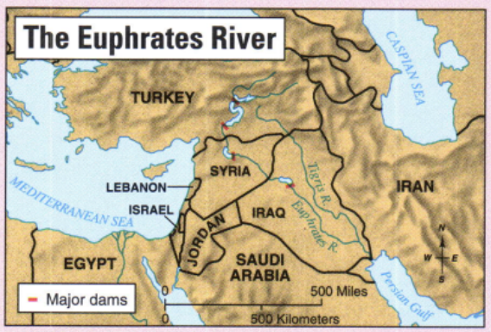
Water security is a vital issue in the Middle East. One country’s source of water often lies in another country. In the case of the Euphrates, it is Turkey that has the upper hand. Turkey’s plan to turn its southeastern provinces into the breadbasket of the Middle East threatens Syria’s supply of drinking water as well as its irrigation systems and hydroelectric power plants.

As population grows in the Middle East, the demands will become even greater and the storages more acute. Tensions in the region, already high because of political differences and age-old rivalries, will be heightened.

1. Why will the question of water rights continue to be an issue in the Middle East?

2. Synthesizing Information: Using the map and the reading, explain why Syria is concerned about the security of its water supply.

Example of how people have ADAPTED to the Euphrates river. | Example of how people DEPEND on the Euphrates river. | Example of how people have CHANGED the Euphrates river.
Note Taking: Mind Maps Chapter 25 Section 1 pages 553 - 555

The
Maghreb

CuCulture
Northern Tier

CuCulture

5 Physical Regions of Middle East

CuCulture

Nile
Valley

CuCulture

Arabian
Peninsula

CuCulture

Fertile
Crescent

CuCulture

Use the Section 1 Reading to add notes to the chart over these 5 topics concerning the Middle East.
Strategic Location | Resource Scarcity | Oil | Ethnic Diversity | Religious Diversity
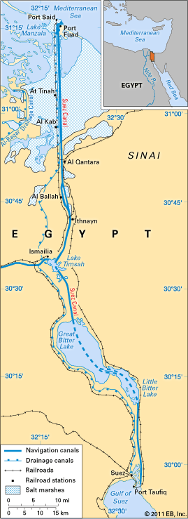
The Suez Canal is a waterway that links the Mediterranean Sea and the Red Sea. It separates the continents of Africa and Asia. It cuts thousands of miles from the routes of ships traveling between Europe and Asia. The Suez Canal is in Egypt. It extends 101 miles through a narrow piece of land called the Isthmus of Suez. The Mediterranean Sea is at the northern end. The Gulf of Suez, a part of the Red Sea, is at the southern end. From the Red Sea, ships can reach the Indian Ocean.

Before the Suez Canal was built, ships sailing between the Mediterranean Sea and the Indian Ocean had to sail all the way around the southern tip of Africa. The canal allows ships to pass directly between the Mediterranean and the Indian Ocean. Before the canal, the voyage from London, England, to Mumbai, India, was 12,400 miles. The canal shortened the trip to 7,250 miles.

A French-owned company built the Suez Canal between 1859 and 1869. For many years France and Great Britain together owned the canal. They agreed that the canal should be open to ships of all countries in times of both peace and war. But in 1956 Egypt took over the canal. France and Britain, helped by Israel, tried to take back the canal by force. They failed. War between Egypt and Israel closed the canal between 1967 and 1975. Today the canal is one of the world’s busiest shipping routes.

Now, take some notes on the Suez Canal, including what it is, where it is located, and why it is important:
1.

2.

3.

TRANSFERENCE: Find the picture, graph, or map on the identified pages, read and analyze the information and answer the question(s).

CAUSE & EFFECT Page 552: MAP STUDY
Why do you think early civilizations arose in the valleys of the Nile and of the Tigris and Euphrates rivers?

APPLICATION Page 555: SCARCITY
How has scarcity of water affected the development of nations in the Middle East?

PARAPHRASING YOUR IDEAS: Using complete sentences, students should paraphrase the excerpts from the text.
Excerpt from text | Paraphrase
Lack of rainfall and scarcity of water have shaped the cultures of the Middle East. Less than 10 percent of the land receives enough water to make farming possible.

Muhammed had met many Jews and Christians on his travels and their beliefs influenced Islam. He accepted the original teaching of the Jewish and Christian scriptures as God’s words. He called the Jews and the Christians “people of the book” because they followed God’s teaching in the Bible.

In traditional Middle Eastern life, Women were expected to be modest and remain secluded within the home. They wore veils to conceal their faces from men who were not family members. In some Muslim homes, women used separate entrances and ate their meals only in the company of other women. This system gave women security.

The Middle East has 60 percent of the world’s oil reserves. Saudi Arabia, Iran, Iraq, Kuwait, Libya and several small states along the Persian Gulf are rich in oil. Except for Iran, all of these states have small populations. A clear division exists between them and their more densely populated poor neighbors. While oil resources are unequally distributed, since the late 1960’s, the entire Middle East has benefited from oil wealth. Oil rich nations have given more money and loans to poor neighbors.

NOTE TAKING – CORNELL NOTES: After you have read pages Chapter 26 Section 3 pages 580-583, complete the Cornell Notes.
TOPIC: Patterns of Life
QUESTIONS: NOTES:
Village Life
1.

2.

3.
NOTE TAKING – CORNELL NOTES: After you have read pages Chapter 26 Section 3 pages 580-583, complete the Cornell Notes.
TOPIC: Patterns of Life
QUESTIONS: NOTES:

Nomadic Life
Nomads:

- The Bedouins:

- Highland nomads:

- Conflicts with settled peoples:

City Life
- Examples:

- Mosques:

- suq

Family Life

- Marriage & Divorce

Lives of Women
1.

2.

3.

Summary:

“Suez Canal.” Britannica School. Encyclopædia Britannica, Inc., 2013. Web. 20 Nov. 2013.

