Geography of Japan
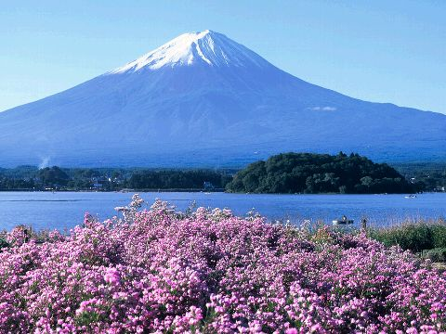
Japan is an archipelago, or chain of islands, that lies off the East Asian mainland. The land area of Japan consists of four main islands: Honshu, Hokkaido, Kyushu, and Shikoku. These are surrounded by more than four thousand smaller islands. These smaller islands are the tops of underwater mountains. The mountains protect the west coast from the tsunamis (tidal waves caused by earthquakes) that pound the east. Japan's terrain is largely mountainous, more than three fourths of the country is covered in mountains, and most large cities are positioned along the coasts. The Japanese archipelago was formed millions of years ago by mountains welling up from the sea. These mountains arose when the tectonic plates collided deep beneath the Pacific Ocean. Volcanoes welled up in the cracks between the plates. Mount Fuji, located west of Tokyo on Honshu Island, is Japan's highest point, with an elevation of 12,388 feet. Japan gets hit by more than one thousand earthquakes every year. Most of them are minor, but some cause serious damage. Japan is surrounded by sea. Warm and cold currents flow through the seas around it, creating an environment that supports a variety of fish species.
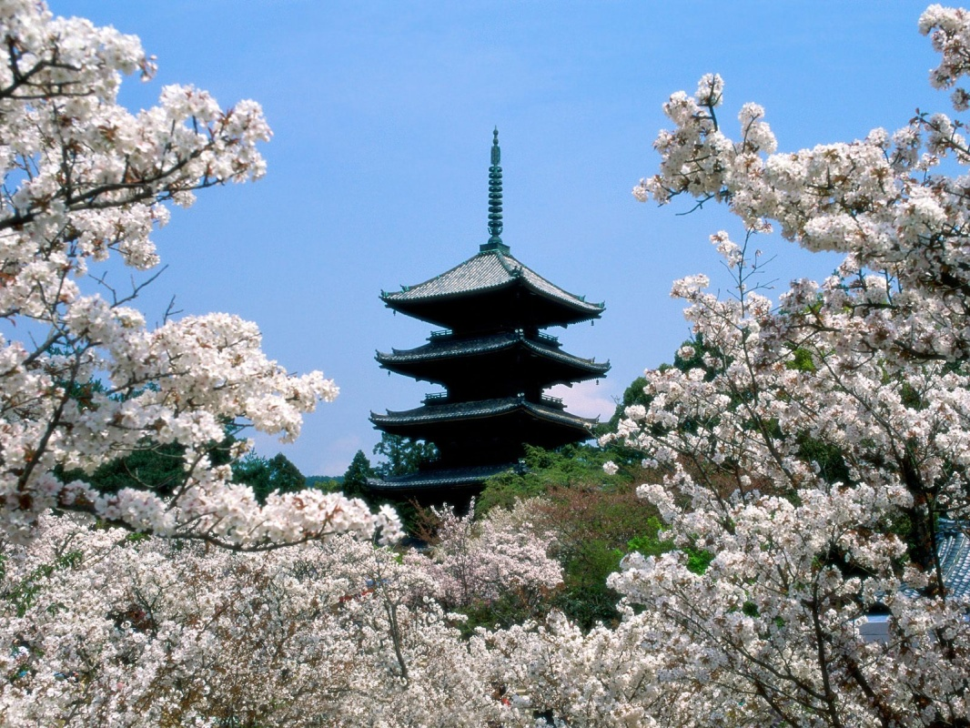
On Hokkaido and in northern Honshu, winters can be bitterly cold. To the south, a more tropical climate prevails. Otherwise, the climate is temperate with warm, humid summers and mild winters. The western side of the islands is usually colder than the eastern side. Japan is subject to typhoons in August and September. The country has four well-defined seasons: spring, summer, autumn, and winter. Each season represents a stage of life to the Japanese people. Two of the most beautiful sights in Japan are the cherry blossoms in spring and the vibrant reds, oranges, and yellows of the autumn leaves. The Japanese people enjoy these signs of the changing seasons and track their progress with weather reports, which feature maps showing where the spring blossoms and autumn leaves are at their best. The far north and south of Japan have very different climates. For example, in March you can go sunbathing in the south and skiing in the north.
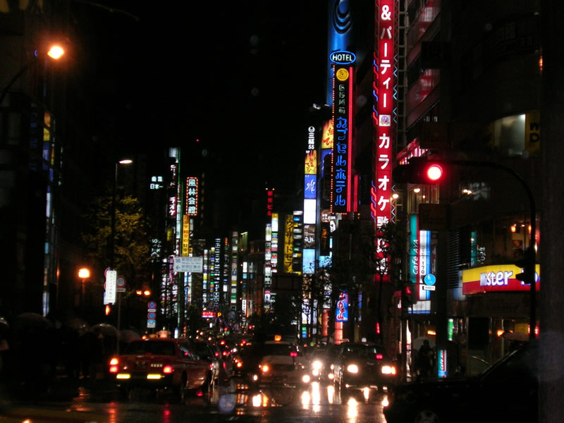
Population Density and Resources
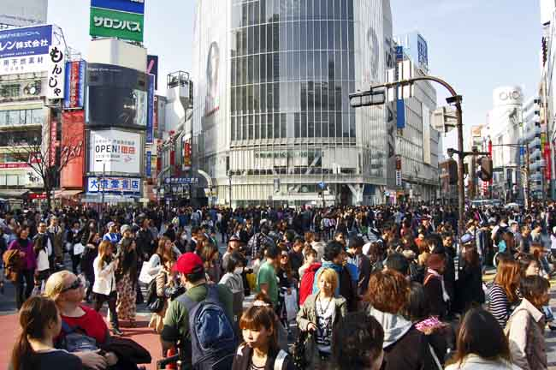
Japan is very densely populated (very compact), with almost 20,000 people living in one square mile. The entire state of New York has about 360 people per mile! Japan's population of 126.8 million is shrinking by 0.24 percent annually. 66 percent of all people live in the cities. Almost half are concentrated in three major metropolitan areas: Tokyo, Osaka, and Nagoya, the largest being Tokyo, housing 35 million people! Tokyo has 50,000 taxis and a subway system that serves 8 million people a day. As a result, Japan suffers from a high cost of living and a lack of affordable urban housing. The Japanese have adapted to a busy rush hour system by creating an extensive and efficient public transportation system. Underground subways whisks commuters from one part of a city to another, while passenger trains run often and are almost always on time- to the minute! Rush hour in Tokyo is an amazing sight.

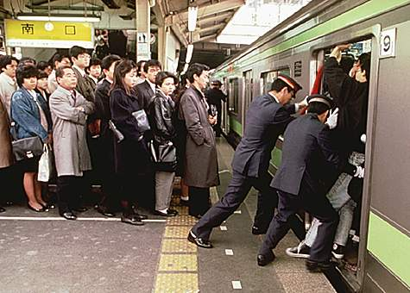
Mobs of commuters bound for work, mix with large groups of uniformed students heading for school. White gloved subway workers, called pushers, stand on the subway platform waiting for the trains to roll in; their job is to shove as many passengers as possible into the cars before the doors close!
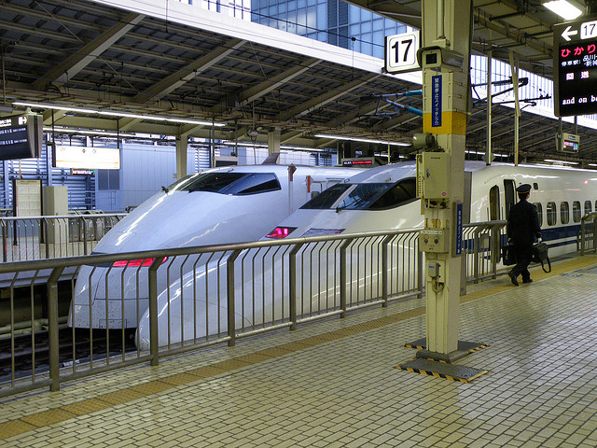
The Japanese have developed some of the fastest trains in the world. Bullet trains- so named for their shape and speed- travel between many cities. The Bullet train races across the Japanese countryside at speeds of up to 180 miles per hour! That’s more than three times as fast as cars, which travel about 60 miles per hour on the highways, in those rare moments when there is no traffic congestion.

Despite their excellent public transportation system, many Japanese own their own cars and love to drive them. As car ownership has increased, traffic congestions has become part of daily life in Japan. Cars create problems even when they are not moving. Finding a place to park in Tokyo is such a headache, that the city has instituted strict regulations about car ownership. Residents in the city cannot own a car unless they can prove they have a place off the street to park it. With parking spaces so limited, Tokyo has pioneered the use of high rise parking lots that look like giant shoe cabinets. These garages use computer controlled elevators to stack cars on top of one another in narrow parking slots.

Japanese Education
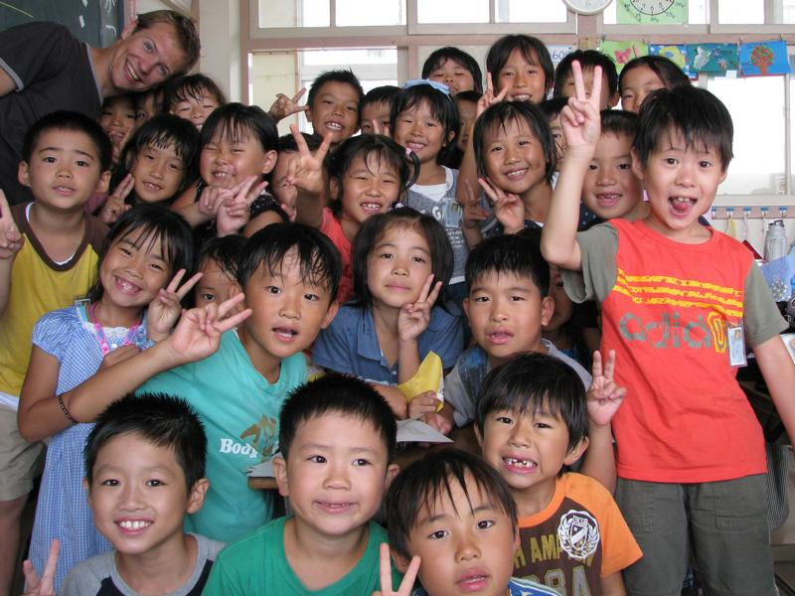
The Japanese educational system is traditionally built on the principles of Confucianism. This was supplemented by the postwar educational reforms that were made in the 1940s to incorporate American forms of education. Education is compulsory (mandatory) and generally free from ages six to fifteen. The basic school system in Japan is composed of elementary school (lasting six years), middle school (three years), high school (three years), and university (four years). 98% of students attend high school. Students usually have to take exams in order to enter high schools and universities. Recently some middle and high schools have joined together to form single, six-year schools. Individuals must pay tuition for education thereafter.
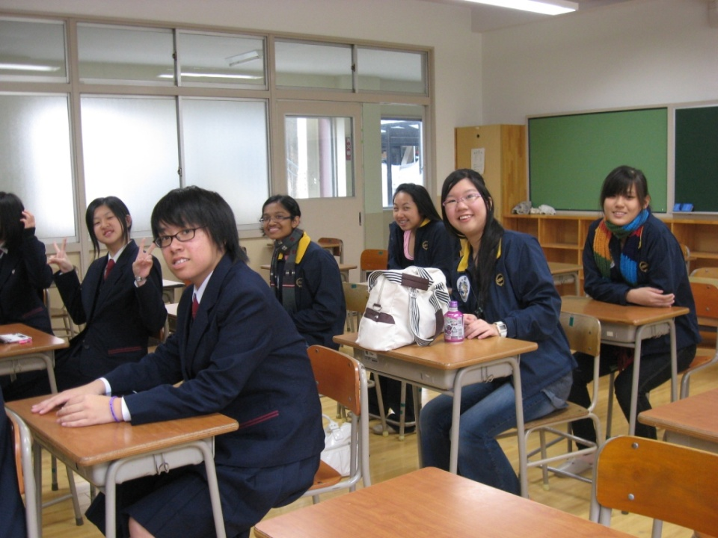
Japanese students attend school five and half days a week, for 240 days a year. Japanese children enter the first grade of elementary school in the April after their sixth birthday. There are around 30 to 40 students in a typical elementary school class. The subjects they study include Japanese, mathematics, science, social studies, music, crafts, physical education, and home economics (to learn simple cooking and sewing skills). More and more elementary schools have started teaching English, too. Information technology is increasingly being used to enhance education, and most schools have access to the Internet. Japanese school emphasis the ideas of working with groups.
Students also learn traditional Japanese arts like shodo (calligraphy) and haiku. Haiku is a form of poetry developed in Japan about 400 years ago. A haiku is a short verse of 17 syllables, divided into units of five, seven, and five syllables. Haiku uses simple expressions to convey deep emotions to readers.
Because education is highly valued, there is great emphasis placed on “winning”, or earning good grades. Students are encouraged to study hard and to compete for good grades. The underlying belief is that hard work and self discipline, rather than natural ability, leads to academic achievement. Mothers become competitive in encouraging and facilitating the learning environment and activities of their children. Many students attend private schools, provided they pass difficult entrance exams (even at the kindergarten level). Parents often enroll their children in juku (cram) schools to help them prepare for these tests. University entrance exams are rigorous, and competition among students is intense. Students study for years and cram for months to take them. Getting into the most prestigious schools is more important than one's ultimate performance. Graduation from the nation's top universities usually guarantees students well-paying jobs and successful careers. There are 460 universities and more than 600 junior colleges and technical schools. It is VERY competitive.
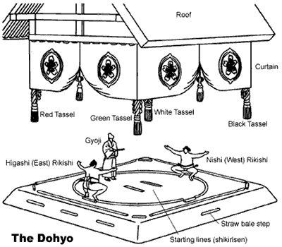
Sports and Recreation
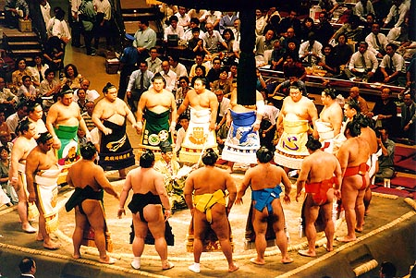
Baseball, soccer, volleyball, tennis, skiing and golf are all popular sports in Japan. The Japanese also enjoy traditional sports such as sumo wrestling, judo, kendo (fencing with bamboo poles), and karate. Sumo wrestling is the largest spectator sport in Japan. The sport of sumo wrestling is about 2,000 years old. A Rikishi, or future sumo wrestler, enters a heya (school) in his mid teens to train. He must live with his trainer and his wife until he is ready to move on to the final level, Sekitori, or the highest rank of a Rikishi. The schools teach rules, etiquette, basic techniques and the history of sumo. Scouts from various “stables”, or sumo training centers, visit schools to recruit promising students who they hope might become the next stars of the sumo ring. Once a young man enters a stable, he must be totally committed to the years of training required to become an accomplished Rikishi. The Sekitori is the only group allowed to wear the knot the top of their head. Sumo wrestlers eat huge meals to gain weight so they can topple the opponent in the ring. All meals are prepared using high protein foods for optimum weight gain. For centuries it was believed that the larger the wrestler’s girth( waist), the greater his chance of becoming a grand champion. However, health problems have plagued sumo wrestlers for decades. Many ailments are a direct result of rapid and excessive weight gain. In an effort to produce healthier fighters, various stables no longer practice force feeding. Others have also adopted weight training and other forms of exercise to create slimmer, yet equally powerful wrestlers. Typically a match lasts only a few seconds, no more than a minute. The elaborate ceremonies before the match are usually longer than the actual competition. Sponsorship of sumo wrestlers is common, and often generous donations from fans are common. One of the most common donations from fans is the very expensive silk apron worn by the sumo wrestlers during the ceremony.
Japanese History
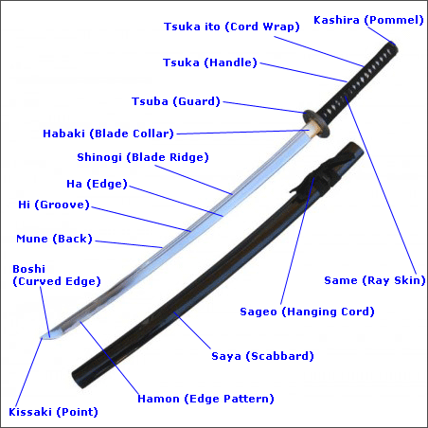
Thousands of years ago, the first Japanese came from what are now China and South Korea. They lived in caves or pits, hunted animals and gathered plants to eat. About five thousand years ago, they began to settle down. They lived in small groups and farmed crops like rice. By AD 300, these small family groups had grown into large clans, or groups of families descended from a common ancestor. Each family inherited its position within a clan. Some were warriors, others were farmers, weavers or potters. Soon, the clans began to fight each other for territory.
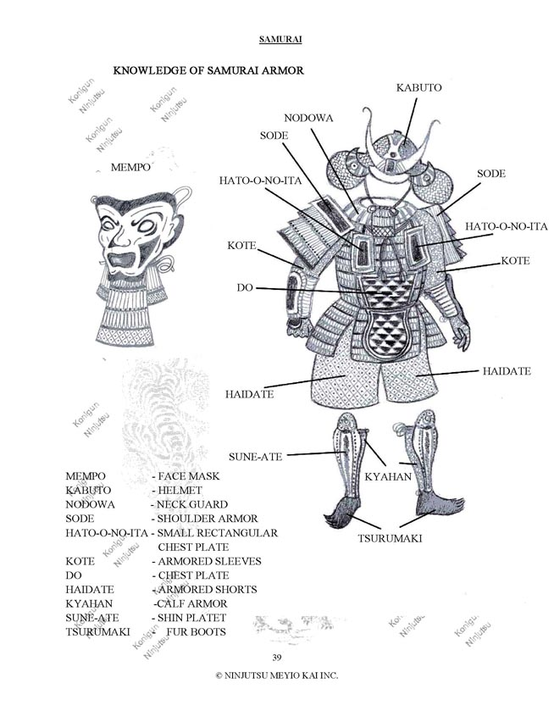
The Yamato clan was the most powerful and created the first empire. During the 1100’s, strong warrior families on the frontier challenged the power of the ruling families. By 1193, Minamoto Yorimoto emerged as the strongest military figure in Japan. The Emperor gave him the title of shogun, or chief general of the army. Under Minamoto and his successors, a feudal system emerged, putting the emperors at the top, followed by shogun and finally the common people (everyone else). The emperors were like kings, but the shogun slowly became the real power governing Japan. The shoguns ran every aspect of feudal life in Japan. In feudal society, loyalty was to the feudal lord first, then to one’s own family. Soon after, the idea of an ultimate warrior developed--- the samurai. These fierce warrior knights waged battles for control of the land with their hand crafted swords. They developed a code of behavior that came to be called bushido, or the “way of the warrior”. It emphasized loyalty above all else. Samurais were expected to demonstrate bravery, self discipline and honor. If this was violated, the samurai was expected to pay a penalty- seppuku ( ritual suicide). Ultimately, the invention of the gun was the end of the samurai.

Bonsai
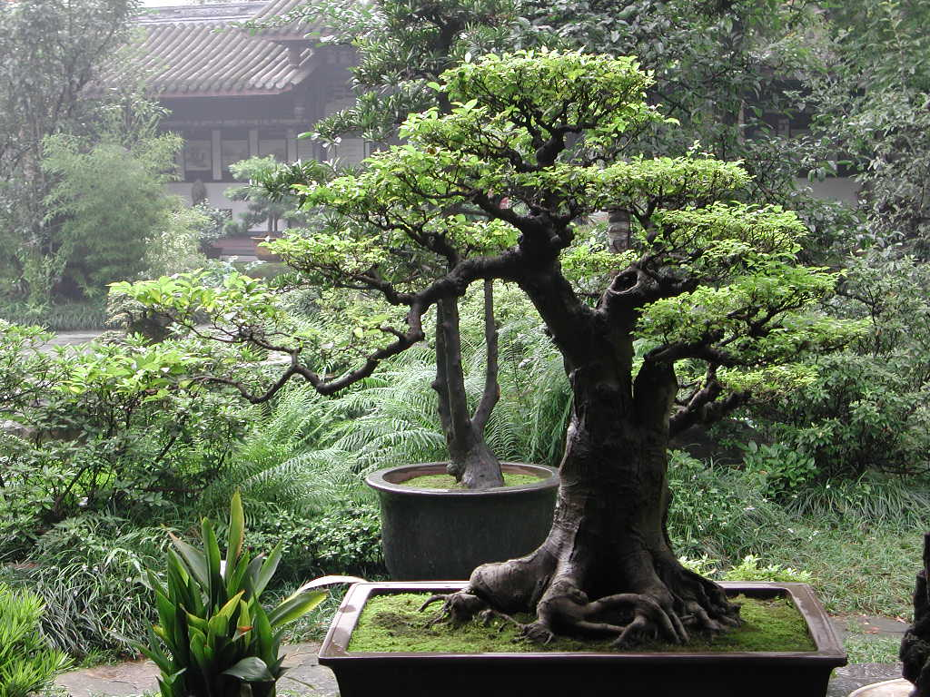
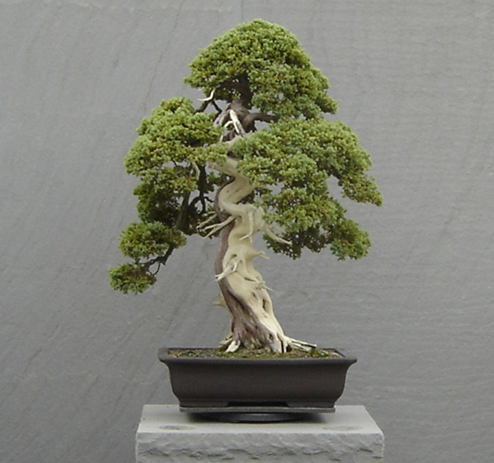
Bonsai is the art of creating miniature scenery with potted dwarf trees. These trees are carefully shaped to produce beautiful shapes of twisted branches. This art originates in Zen Buddhism. It is a form of artistic expression and reverence to nature, in a place were limited space allows for few parks. Bonsai is a way of demonstrating nature in miniature. These are actually real trees, but are not really suitable for house plants. Bonsai is viewed as a hobby that allows a great understanding and connection with nature, and a way to enhance gardens. This is a skillful art form and one tree can sell for thousands of dollars.

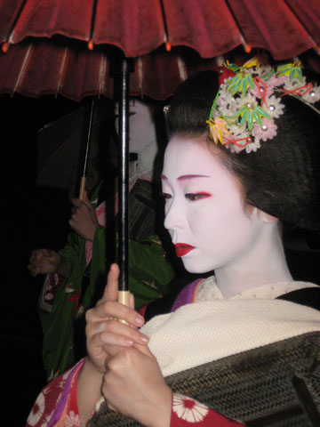
Geishas
Geisha translates to “a person of the arts”. The first know geishas were men, who performed dances, music and poetry for the wealthy. Today, young girls enter into school at about age 15, and spend five years training at the hanimici- These young women in training are known a maiko. They are extensively trained in the art of ancient dance, singing, playing instruments, tea ceremony, dress (kimono), calligraphy and flower arranging. Today, the traditional makeup of the apprentice geisha is one of their most recognizable characteristics, though established geisha generally only wear full white face makeup characteristic of maiko during special performances.
The traditional makeup of an apprentice geisha features a thick white base with red lipstick, and red and black accents around the eyes and eyebrows. Originally, the white base mask was made with lead, but after the discovery that it poisoned the skin and caused terrible skin and back problems for the older geisha towards the end of the Meiji Era, it was replaced with rice powder.
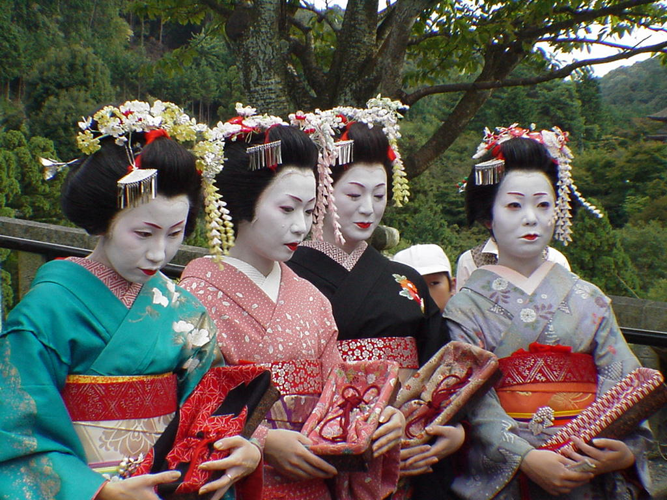
The application of makeup is hard to perfect and is a time-consuming process. Makeup is applied before dressing to avoid dirtying the kimono. First, a wax or oil substance, called bintsuke-abura, is applied to the skin. Next, white powder is mixed with water into a paste and applied with a bamboo brush, starting from the neck, and working upwards. The white makeup covers the face, neck, and chest, with two or three unwhitened areas and a line of bare skin around the hairline, which creates the illusion of a mask.
After the foundation layer is applied, a sponge is patted all over the face, throat, chest, the nape and neck to remove excess moisture and to blend the foundation. Next the eyes and eyebrows are drawn in. Traditionally, charcoal was used, but today, modern cosmetics are used. The eyebrows and edges of the eyes are colored black with a thin charcoal.
The two most famous haniminic ( geisha quarters) are found in Tokyo and Kyoto. This practice still exists today, but it is a minor role, reserved mostly for entertaining tourists. The beginning of World War II saw a decline in geishas, as most women were working at factories. At one time there were over 80,000 in Japan with , about 1,000 living in Kyoto. Today there are about 80 trainees.

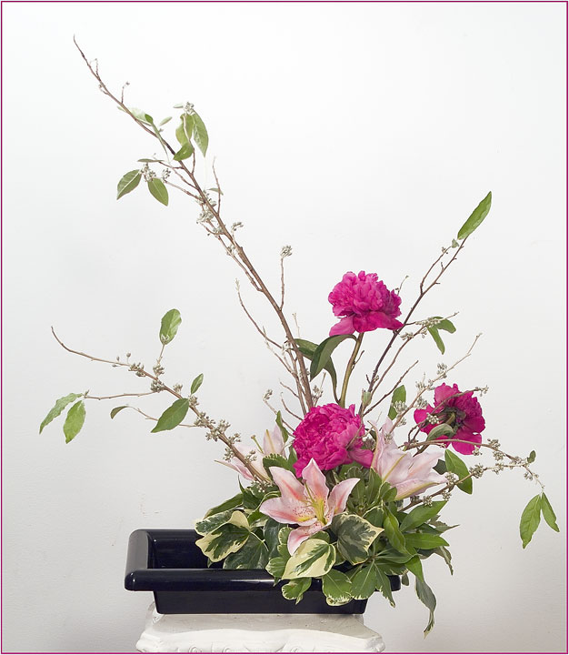
Ikebana- Flower Arranging
Ikebana was started by a Buddhist monk in the early 15th century. It is designed to recreate elements of nature-seas, rivers, and valleys- for the inside and stresses the harmony of vases, stems, leaves, branches and flowers. Due to the geography and religion of Japan (Shinto), they have a reverence towards nature and hope to bring it into their homes. Historically, specific guidelines were to be followed using precise geometric angles. However, modern examples stress choosing the flowers you like, and placing them in an appropriate container. This is done in respect for the guest who will see it! This art form was originally reserved for the upper class, but became widely available to more people after World War II. American Housewives became interested and began to study this ancient art form. Today, about 15 million people practice Ikebana, mostly young women.
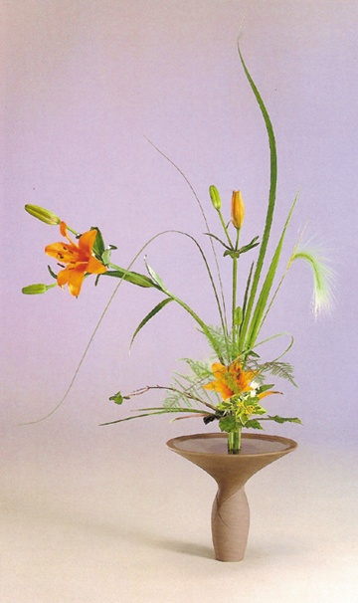

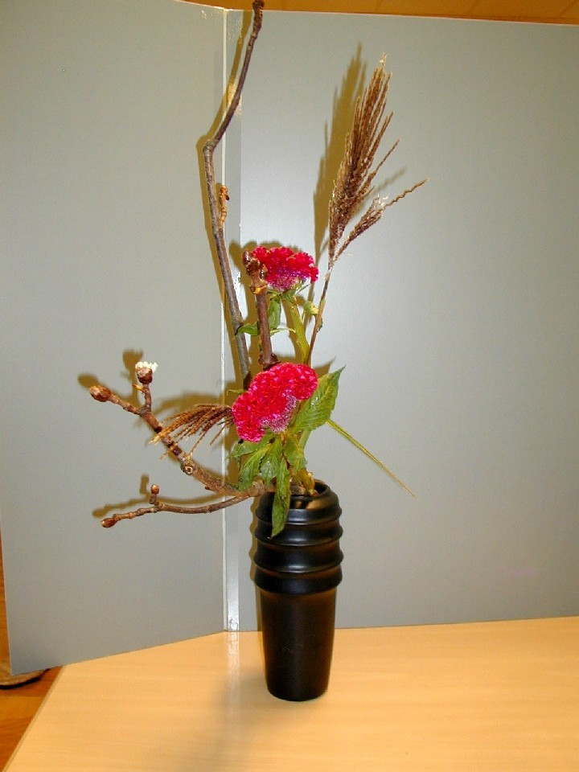

Japanese Food and Culture
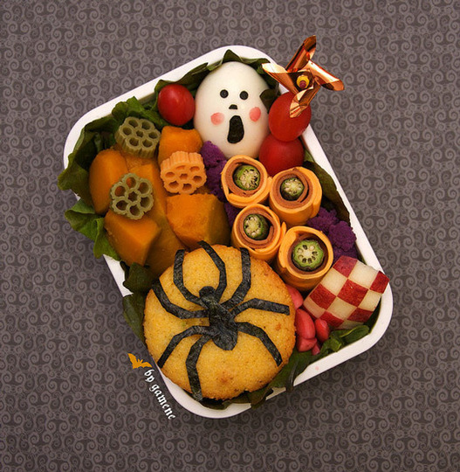
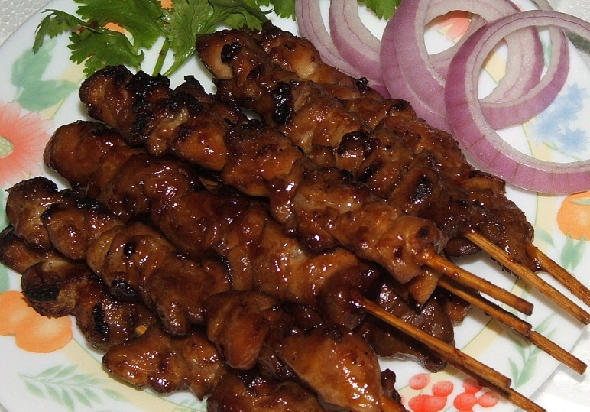
Although many young Japanese eat while walking in public, it is generally considered bad manners for adults to do so. Therefore, snack foods sold at street stands are eaten at the stand. In a traditional meal, people typically eat from their bowl while holding it at chest level, instead of bending down to the table. It is not impolite to drink soup directly from the bowl or to make slurping sounds. Japanese use chopsticks (called hashi) to eat most meals but generally eat Western-style food with utensils. The main meal is eaten in the evening. Western style food is becoming very popular among the young people of Japan. Often families will serve two different meals: one for the young people such as pasta, hamburgers and pizza and another for the older members of the family that enjoy the traditional Japanese cuisine. Japanese people eat small meals frequently throughout the day. Bento lunches, which are boxed lunches made at home or bought from shops all over Japan, are very popular for school lunches. Traditional bento lunches includes rice, pickles, grilled fish or meat and vegetables.
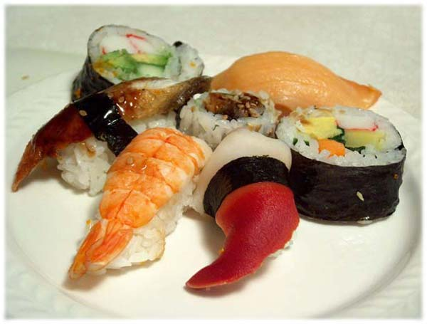
Rice is eaten at nearly every meal. The Japanese also like to eat onigiri (rice balls wrapped in seaweed). The Japanese have a wide variety of dishes that are popular. Sushi is rice and fish (cooked or raw) served together in a special way. Sushi is very expensive and is reserved for special occasions. Tempura is another popular dish in Japan. Tempura is seafood and vegetables dipped in batter and then deep fried. Shabushhu are thin slices of beef with sesame and sauce, with vegetables in broth. Yakatori is broiled chicken on a skewer with green peers, garlic cloves and onions served with a tangy sauce. A favorite street snack is takoyaki, which is a batter mixed with octopus, onion, fish and seaweed flakes that are rolled into dough balls and eaten along with a sauce. Noodles (ramen and others) are popular, and so is tofu (bean curd). People drink tea with every meal.

Wood Block Prints
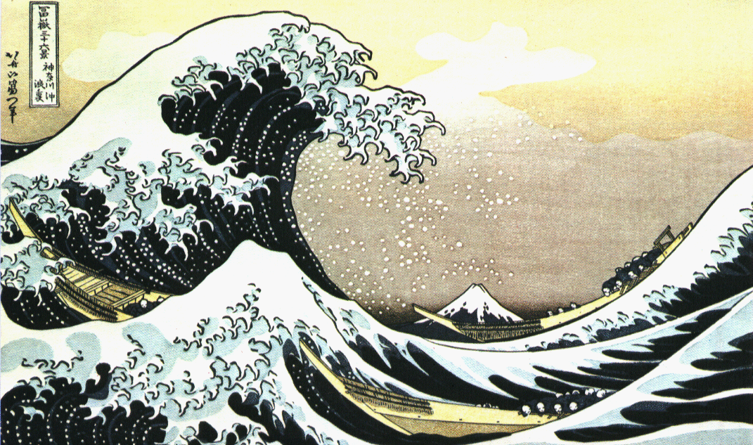
At the end of the feudal period in Japan, Japanese artists developed new styles that reflected the interest and tastes of the growing middle class. Among the best-known works of this period are brilliantly colored woodblock prints of city life called ukiyoe. Ukiyoe is unique because it is not just one person that is creating the art. A wood carver, a colorist, a printer and a publisher all work together to create the piece. This idea of working together is common in all aspects of Japanese life. Originally, wood block prints were created as an inexpensive way for the Japanese middle class to decorate their home. Ukiyoe influenced art styles in Europe; painters like Degas and Van Gogh used these techniques during the Impressionism era.
Hokusai "In the Hollow of a Wave off the Coast at Kanagawa", 1827

No. 2. Mount Fuji in Clear Weather. This often also known as "Red Fuji".
