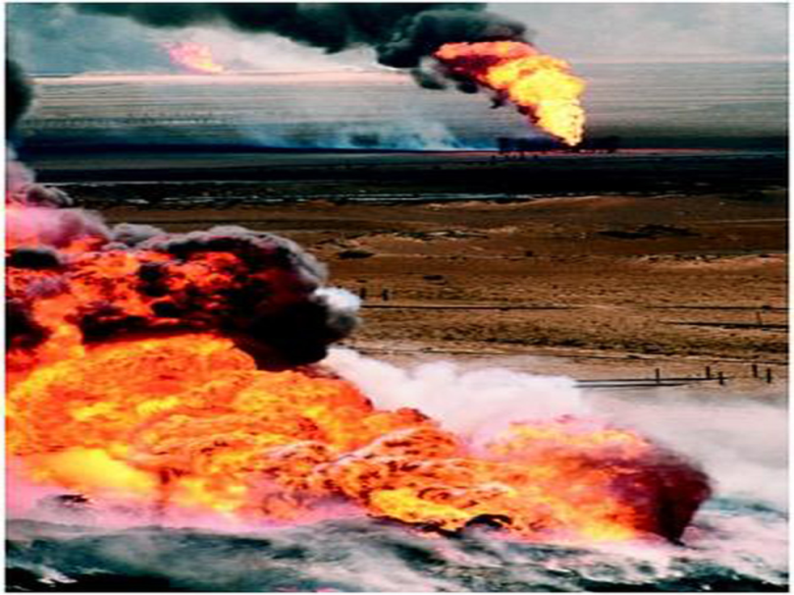
Station 5: Persian Gulf War- Operation Desert Storm
Iran- Iraq war ends in 1988 with HUGE losses to both sides and the Iraqi people are very upset with the unrest in the country. Saddam Hussein was looking for a “quick fix” to build up public support. Saddam announces to the world that Kuwait “belongs” to Iraq, knowing Kuwait has vast oil reserves. Saddam Hussein invaded Kuwait on August 2, 1990.
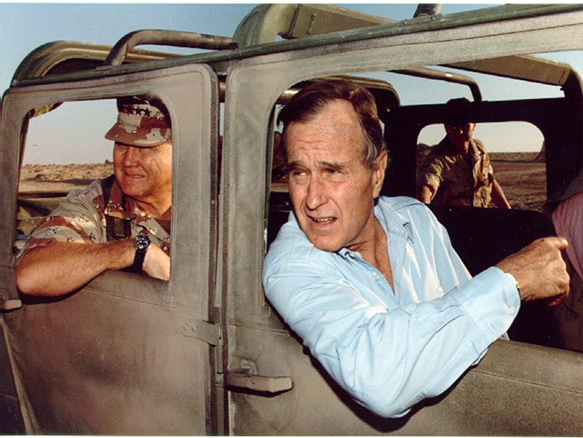
The global community reacts by imposing trade embargos against Iraq. Soon the US and UN put together a coalition of forces( US, Europe and Arab nations) to attack. On January 16-17, 1991- collation forces move against Iraq by land and air. The key players in this event are President George H. Bush and General Norman Schwarzkopf, leader of the collation forces. The Iraqi army used a “scorched earth” technique when dealing Kuwait- they continued to set fire to 600 oil wells. Many Iraqi troops surrender with ease due to the terrible conditions ( lack of food, non-payment, lack of supplies).

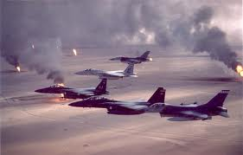
Results
After the war, several Iraqi groups compete for power- Saddam continued to hold power and the UN maintains trade sanctions against Iraq. Throughout the 1990’s UN weapons inspectors found a variety of weapons and banned technology. The world learns that Saddam had committed horrific crimes against the Kurds and is concerned he is still in power. The UN decides it will lift sanctions ONLY if the Iraq weapons programs will be dismantled. Iraq continues to break UN bans and in 1993 President Bill Clinton orders more air strikes, but Iraq continues to refuses to let in UN inspectors. Slowly, we see trade between Iraq and other Arab nations opens.

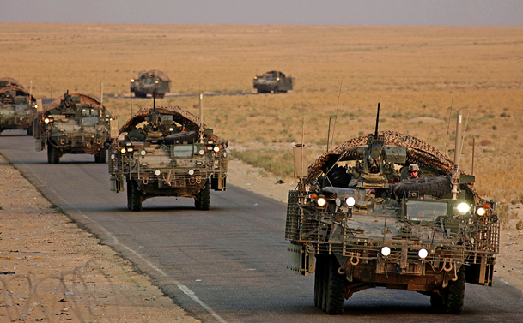
Operation Iraqi Freedom
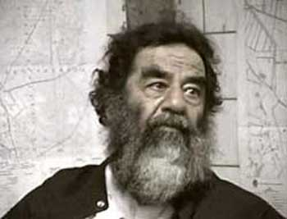
After the events of September 11, 2001, President George W. Bush refers to Iraq as part of the “Axis of Evil”, believing that Iraq was harboring terrorists and that they still held weapons of mass destruction. On November 8, 2002- UN demands that Iraq allow in inspectors but it takes until early 2003 for President Bush and British Prime Minister Tony Blair to declared that Iraq was actually continuing to hinder UN inspections and that it still retained proscribed weapons. While Iraq appears to comply and stop interfering with the UN inspectors, many other UN nations asked to give Iraq more time to comply ( France, Germany, Russia). On March 17, 2003-George W. Bush gave an ultimatum to Saddam, giving him 48 hours to leave Iraq. The leaders of France, Germany, Russia, and other countries objected to this buildup towards war. March 20, 2003- the Allied Forces launch an attack on Iraq. Saddam Hussein was captured on Dec. 13, 2003. In June 2004, he stood trial for various crimes and was convicted of crimes against humanity and was executed on Dec. 30, 2006. In January 31, 2005, Provisional elections held in Iraq and by May 2005 is the bloodiest month seen in Iraq since the invasion. As the war looms on, public opinion for the war decreases. Despite public opinion in 2007, 20,000 more U.S .troops added to Iraq.

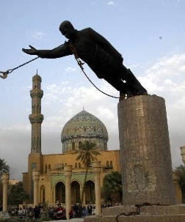
Operation New Dawn
In November 2008 an agreement for a timetable for withdrawal of U.S. forces. U.S. troops were scheduled to leave the cities by mid-2009, and withdrawal from the country was set to be completed in early 2012. In February 2009 President Barack Obama announced that U.S. combat forces would be withdrawn from Iraq by August 2010, with the remaining troops due to pull out by December 2011. January 31,2009 provincial ( state) elections held and 50,000 troops will remain for training. The last troops leave Iraq on December 15, 2011

