**Nationalism & Government**

This small sampling of recent headlines about turmoil in the Middle East—and countless others in the last century—raises the question: Why is that part of the world such a mess? It's complicated, of course, but the fact is that many of the current conflicts can be traced to decisions made after World War I by the victorious Allies (largely Britain and France) who divided up the territory of what had been the Ottoman Empire.

In drawing the boundaries of what would become today's Iraq, Jordan, Israel, Syria, and Lebanon, they paid little attention to the ancient tribal, ethnic, and religious differences that are at the root of much of the bloodshed in the region 90 years later. The result, according to historian David Fromkin, was the creation of a group of neighboring "**countries that have not become nations even today**."

Beginning in 1914, the war in Europe pitted Britain, France, Russia, and eventually the United States, against Germany, Austria-Hungary, and the Ottoman Empire. Ruled since 1299 by Muslim sultans in Constantinople (now Istanbul, Turkey's biggest city), the Ottoman Empire spanned southeastern Europe, North Africa, and the Middle East.

After the Allies' victory in 1918, peace talks took place in Versailles, outside Paris. But there and in follow-up negotiations, the Allies disagreed about what the postwar world should look like: They argued not only about how severely to punish Germany, but also about what should happen to the Ottoman territories, which were home to many ethnic and religious groups, including Turks, Arabs, Kurds, Muslims, Christians, and Jews.

Nationalism was a growing force in the early 20th century and President Woodrow Wilson advocated self-determination. In his Fourteen Points, Wilson urged that all nationalities within the former Ottoman Empire be assured "an absolutely unmolested opportunity of autonomous development."

But the Europeans were more intent on preserving, and even expanding, their colonial empires, and they wanted access to oil, which was starting to be discovered in large quantities in the Mideast.

The Europeans also wanted to loosen Islam's hold on the region by promoting secular government. But, as Fromkin writes, foreign powers trying to impose their own order would not be welcomed in places "whose inhabitants for more than a thousand years have avowed faith in a holy law that governs all life, including government and politics."

**Notes**

**Questions**

What is nationalism?

What type of government were they used to?

**Connection to Imperialism in Africa**

**Iraq Divided**

Further complicating matters, the British had made a number of conflicting commitments during the war: They had promised Arabs independence in return for taking up arms against their Turkish Ottoman rulers. In 1917, in what became known as the Balfour Declaration, Britain announced its support for a "national home for the Jewish people" in Palestine. Finally, they made a secret agreement with their French allies to divvy up large chunks of Ottoman territory between them.

By the end of all the peace conferences in 1922, Britain and France had received "mandates" from the newly formed League of Nations to oversee much of the former Ottoman Empire, where they created several new states and installed figurehead rulers. But even then, Colonel Edward House, Wilson's confidant, gloomily predicted that the lines drawn in the desert sand by European diplomats were "making a breeding place for future war."

Here's how events unfolded:   
"In 1919," the historian Margaret MacMillan recalls, "there was no Iraqi people; history, religion, geography pulled the people apart, not together."

The Shiite and Sunni sects of Islam had split centuries earlier over who would succeed Muhammad as Islam's leader.

But in creating the new nation of Iraq in ancient Mesopotamia, Britain cobbled together the Ottoman provinces of Baghdad (mostly Sunni), Basra (mostly Shiite), and Mosul (mostly Kurdish).

What kept Iraq together for more than 80 years was the autocratic rule of kings and dictators. In 1921, the British installed as king an outsider named Feisal, the son of the ruler of the holy city of Mecca (in present-day Saudi Arabia), who was a British ally during the war.

The monarchy was overthrown in 1958. After several military coups, the socialist Baath Party seized control in 1968 and brought to power Saddam Hussein, who was toppled by the U.S.-led coalition in 2003. Since then, without a strongman holding Iraq together, rising sectarian violence has brought the country to the brink of civil war.

**Notes**

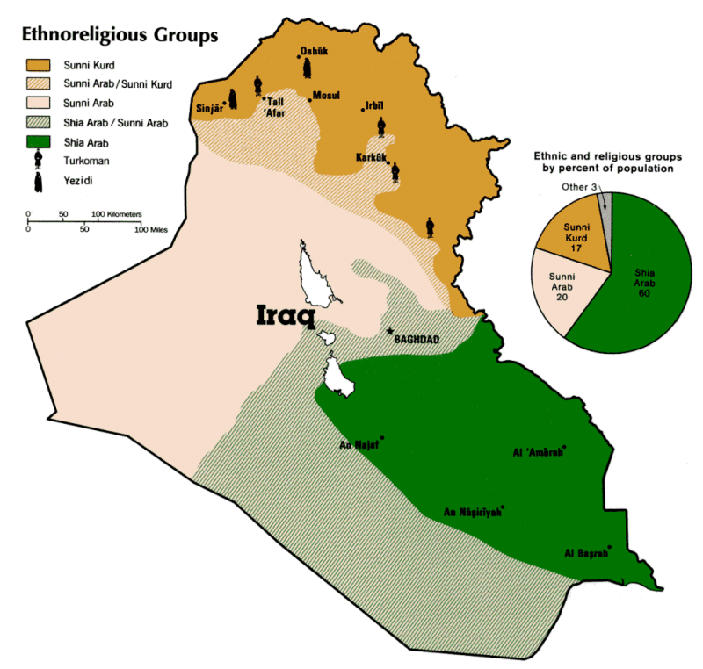

**Questions**

What might have been a better way to divide up Iraq based on the map?

Autocracy is another word for?

In what way was Saddam Hussein good for Iraq?

**Connection to Imperialism in Africa**

**The Middle East After the World Wars**

The British mandate for Palestine included present-day Israel, Jordan, and the West Bank and Gaza Strip. In 1921, on the land east of the Jordan River, Britain carved out Transjordan and placed Feisal's brother Abdullah on the throne. Jordan was granted independence in 1946, and Abdullah was assassinated in 1951. The current King, Abdullah II, is his great-grandson.

West of the Jordan River, the issue of a Jewish homeland played out over the next two decades. Most Arab leaders opposed the creation of a new Jewish state in Palestine, where the population was largely Arab. Supporters of Zionism (the nationalist movement for a Jewish homeland in Palestine) argued that additional Jewish settlement would benefit the entire region economically, and that Jews had a right to a state in the land of ancient Israel. The murder of 6 million Jews in the Holocaust during World War II increased world pressure for a Jewish homeland.

In 1947, the United Nations voted to partition the narrow slice of land between the Jordan River and the Mediterranean Sea into Jewish and Palestinian states. While Jewish leaders accepted the U.N. plan, the Arab states rejected it and attacked the newly declared state of Israel when the British left in May 1948.

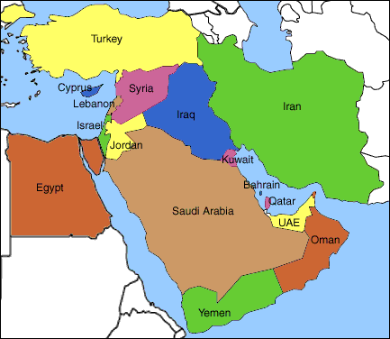Other Arab-Israeli wars followed. The Six-Day War in 1967 left Israel in control of the Sinai Peninsula (later returned to Egypt), along with the West Bank, the Gaza Strip, the Golan Heights, and all of Jerusalem.

In 1993, an agreement between Israel and Palestinian leaders granted Palestinians limited control of the West Bank and Gaza, in anticipation of a future Palestinian state. Little progress was made toward that goal in the years that followed. The victory in last year's Palestinian elections of the militant group Hamas, which advocates the destruction of Israel, virtually froze peace efforts.

**Notes**

What is Zionsim?

What is Hamas and what do they want?

**Connections to Africa**

**Modern Boarders**

In 1920, Syria became a protectorate of France, which claimed a special responsibility for safeguarding Christian enclaves in the Ottoman Empire. France carved out Syria's coastal region into the separate state of Lebanon, whose legitimacy the Syrians still don't recognize. Lebanon gained independence in 1943. Strife between Christians and Muslims developed, by 1975, into a 15-year civil war. The Lebanese invited Syria to intervene, but Syrian troops remained until 2005. They left after Syria was accused of ordering the assassination of a former Lebanese Prime Minister.

Under the Ottomans, Kuwait was at one time a district of Basra and was later overseen by Britain, until independence was granted in 1961. In 1990, Saddam Hussein invaded Kuwait, citing its historical connection to Iraq, and touched off the first Gulf War. A U.N.-sanctioned coalition, led by the U.S., liberated Kuwait early in 1991.

Today, three generations after the end of World War I, it seems that President Wilson's aide, Colonel House, was right in his dire prediction for the Middle East. The question is, will the conflicts there ever cease?

Professor Fromkin recalls that after the collapse of the Roman Empire, Europe struggled for 1,500 years over what form of Christianity to follow and whether Europeans should be ruled by popes or kings. He wonders why the Arabs should be any different.

"The continuing crisis in the Middle East in our time may prove to be nowhere near so profound or so long-lasting," he writes. "But its issue is the same: how diverse peoples are to regroup to create new political identities for themselves after the collapse of an ages-old imperial order.

**Notes**

**Questions**

**How did the Persian Gulf War Start?**

**What happens after Empires End?**

**So why is there so much fighting in the Middle East?**

**Connections to Africa**