Chapter 2Live.
published feb. 21, 2014
Chicago Tribune

In China’s housing blocks, quality of life is the missing ingredient
aboard the beijing-to-shanghai bullet train

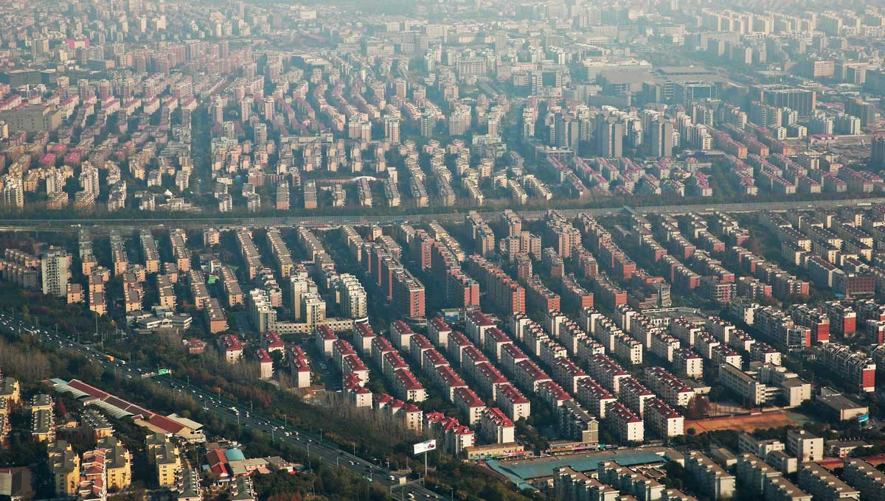
As the train rockets through the Chinese countryside at 200 mph, the view out the window is, at first glance, eerily familiar: row after row of monotonous high-rise housing blocks that recall notorious Chicago public housing projects like the demolished Robert Taylor Homes. Construction cranes are building even more.

But China’s mass urban housing is more complex than it appears. Many of the apartment blocks are filled with middle-class families that enjoy modern conveniences like central heating and private showers, which were unavailable to millions of ordinary Chinese as recently as 20 years ago.
By a purely utilitarian yardstick, the scale of the vast new Chinese housing complexes — and the speed with which they’ve been constructed — is remarkable. In less than a generation, the Chinese have erected thousands of residential towers, upgrading living conditions for millions of families. But a chorus of critics contends that a crucial ingredient is missing from the high-rise housing boom: enhancing the shared quality of urban life.

China's urban boom on a global scale
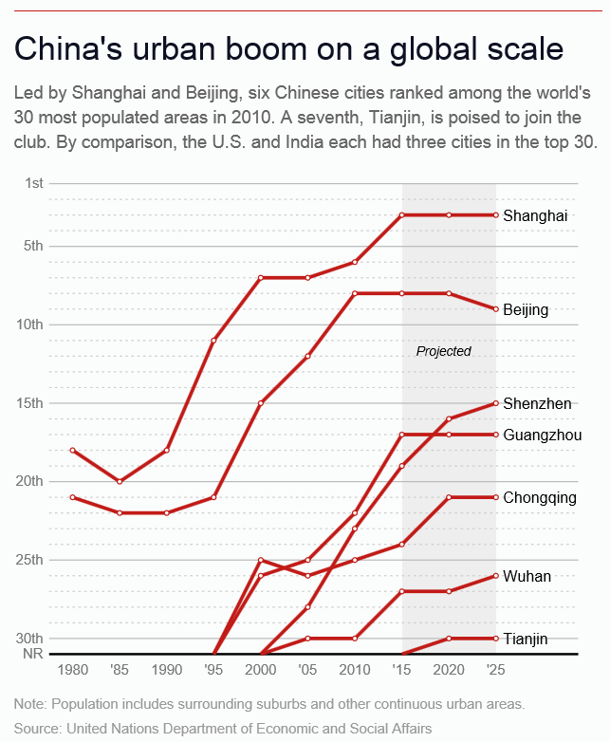
Led by Shanghai and Beijing, six Chinese cities ranked among the world's 30 most populated areas in 2010. A seventh, Tianjin, is poised to join the club. By comparison, the U.S. and India each had three cities in the top 30.
In this view, the apartment blocks are sterile, one-dimensional districts whose residents lack easy access to services like hospitals and schools. Many encourage driving, worsening China’s air pollution — a problem reaching new heights this week as toxic smog blankets Beijing and other cities in northeast China. Above all, the critics say, the blocks’ Orwellian sameness extinguishes architecture’s ability to express time, enliven space and enrich the human experience. Even Chinese filmmakers have taken aim.
In the 1997 movie “Spicy Love Soup,” a young Chinese man and his lover go to his high-rise apartment. The next morning, she goes out to buy food but gets lost amid the look-alike buildings. She goes to building after building and knocks on door after door — to no avail. At the end, she stands helplessly in the middle of the concrete forest.
The moral of the story: Amid the relentless repetition of the high-rises, “even love is lost,” said University of Illinois at Chicago political science professor Yue Zhang, author of “The Fragmented Politics of Urban Preservation: Beijing, Chicago, and Paris.”
Doing better won’t be easy. There are seemingly no rules for China’s skyscrapers, which come in a variety of attention-getting shapes (a dragon, a pair of pants, a bottle opener). But for the nation’s apartment towers, there is seemingly nothing but rules.
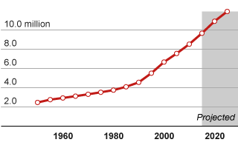
Codes and cultural preferences deriving from the traditional feng shui system of orienting buildings lead the vast majority of new apartment buildings to face south. In most large cities, experts say, the codes even mandate that an apartment’s living room get at least two hours of direct sunlight on the shortest day of the year.

Tianjin
2010 Population: 8.5 million
Note: Population includes surrounding suburbs and other continuous urban areas.
Source: World Urbanization Prospects 2011 revision from the UN
As eager participants in the building explosion fueled by China’s urbanization, Chicago architects have tried with little success to cope with these creativity-crushing constraints. Perkins+Will, whose portfolio includes O’Hare‘s international terminal, have sworn off housing in China after a high-end condominium project the firm designed in the fast-growing northern city of Tianjin was compromised by changes the architects could not control.
Others, including VOA Associates, which worked on the 1995 renovation of Navy Pier, steer clear of run-of-the-mill block housing and instead design homes for China’s burgeoning crop of millionaires. One example: a Spanish Revival complex, complete with red tile roofs and orange-colored concrete walls, tucked amid the green hills of the southern boomtown of Shenzhen.
“What they’re trying to do is reach out and connect to culture, whether it’s theirs or someone else’s,” VOA architect Chris Groesbeck said as he toured the Shenzhen complex. “They’ve been starved with this relentless pragmatism.”
Chinese leaders and builders see things differently. The housing blocks are an integral part of a government-directed migration from farms to cities that has already lifted half a billion people out of poverty and that experts predict will increase the number of Chinese urban dwellers to 1 billion by 2030. For their part, the builders say customers embrace the look-alike towers because the high-rises give each complex a distinct identity within China’s vast urban transformation.
“They want an overall plan. You know it’s the same development,” said Hu Bin, a director of engineering for Agile Property Holdings, a Chinese company that’s building more than 30 residential towers on the outskirts of the southern city of Guangzhou. When completed, the high-rises will house 30,000 people.
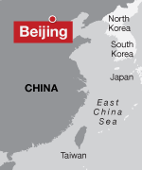
The system has little time for time-consuming, cost-escalating architectural nuance. The question is: What’s the alternative? Can the Chinese do better?

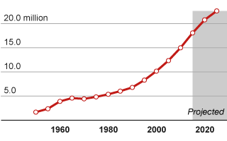
Beijing
2010 Population: 15.0 million
To get a feel for how Chinese city dwellers used to live, stroll down one of old Beijing’s narrow lanes, called hutongs. They’re lined with siheyuans, tightly packed one-story houses built around an inner courtyard. Some date to the Yuan Dynasty in the 13th century.
American houses are surrounded by lawns and other open space. In China, the courtyard homes enclose open space.
American houses also reflect American individualism. The house is an expression of its owner. Its windows and front door suggest the eyes and nose of a human face.
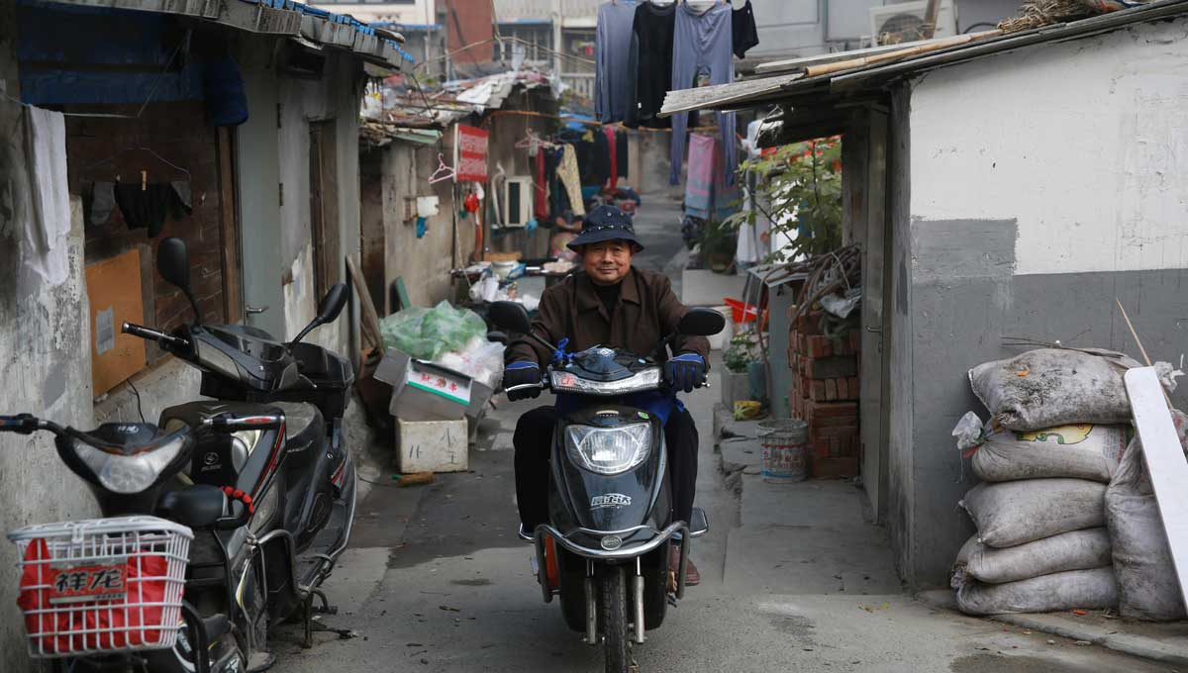
Beijing’s courtyard houses reflect the values of a culture that puts far more emphasis on the family and society. Their walls are punctuated only by the main entrance gate or an occasional window. The ballet of city life that plays out beyond those walls, however, is vital and vivid.
A man rides a scooter through a traditional alleyway in the eastern Chinese city of Nanjing.
The noise of Beijing’s wide, car-dominated streets fades away. With the houses small, the lanes serve as gathering places, not just passageways. You hear the click-click of tiles as women play mahjong on an outdoor table, or a man on a motorized bike calling out “feipin, feipin.” That’s Chinese for “recycled materials,” which he’s collecting.
“They sleep in their houses, but they live in the streets,” said Benjy Ward, a former Asian regional design director for Gensler who now works in the firm’s Chicago office. The houses range from rehabbed, fully modernized places for professionals to primitive, overcrowded homes for migrant families — as many as four sharing a single home. Few have central heating. Or plumbing. Many residents must walk to a public toilet as well as a public shower. Despite these inconveniences, residents like Fan Xinghua, 35, insist that they like the communal living.
“Everyone knows each other here,” she said as she hung laundry on a clothesline. “That’s good for the children. They have lots of others to play with.”

A look inside a Beijing hutong
But the hutongs are no longer the Beijing norm. In the 1950s, Beijing had more than 7,000 of the alleys. Now, by some accounts, there are only about 1,000.
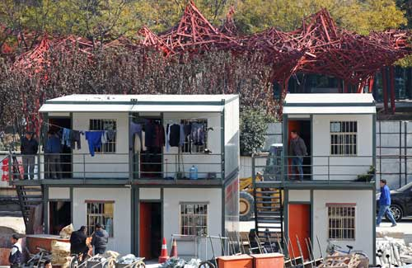
In their place is a new city: modern rather than ancient, vertical rather than horizontal, with wide roads rather than narrow lanes. Le Corbusier, the Swiss-born architect who in the 1920s envisioned a radical, never-realized remake of Paris along these lines, might have approved.
The residents of the apartment blocks are the lucky ones. Soaring costs have priced many Chinese out of the high-rises. Scores of migrant workers who flock to Chinese cities for construction jobs live in tiny prefab apartments stacked on the rim of building sites. Still others cram into low-rise courtyard houses or small apartment buildings, shunted to the margins of society.
Workers in temporary on-site housing units move about on the construction site of the Shanghai Nature Museum. The museum was designed by the Chicago office of the architectural firm Perkins+Will.
Chinese call them “the ant tribe,” said Zhang, the UIC political science professor. The urban growth machine that built the towers is a unique hybrid of communism and capitalism.
In keeping with communist ideology, the government owns urban land but leases it to private developers. The leases pay for social service programs that the central government forces local governments to provide. The local governments desperately need the revenue because they don’t collect property taxes.
To maximize profit, developers build tall, identical structures and refrain from giving them architectural frills. The cookie-cutter towers keep architectural fees low and enable construction workers, some of whom are migrant workers with little training, to repeat simple tasks.
Chinese architects design most of the high-rises. Acclaimed foreign firms, which charge higher fees, typically get showcase projects like new skyscrapers and museums. The most creativity, in other words, is devoted to the buildings with the least impact on daily life.
As a visit to one of Beijing’s largest housing complexes reveals, the high-rise boom has raised individual living standards. The complex, located outside Beijing’s fifth ring road and known as Tiantongyuan, is reportedly home to at least 400,000 people — more than the population of Cleveland.

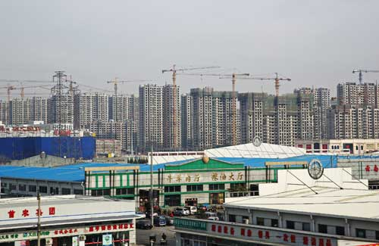
Construction cranes build a housing block on the outskirts of Beijing.
Buying sweet potatoes from a peddler, He Zengqin, 80, said she moved to the area from a six-story apartment building in old Beijing. “The air is better here,” she said. “As an old person, that’s something we really value.” She also appreciates such modern conveniences as a shower and taking an elevator to her apartment rather than walking up six flights of stairs.
But critics say the housing blocks exact a collective cost because they often sit on the urban periphery.
In Beijing, the outlying areas have far fewer public services than high-income areas close to downtown, according to an upcoming report by researchers at Beijing’s Tsinghua University. The inner areas were home to 32 percent of the city’s population but had more than 60 percent of the best schools and hospitals, says the study.

“It’s sprawl, basically, sprawl at the expense of migrants,” said Jonathan Woetzel, a Shanghai-based director of the McKinsey Global Institute. Other costs, critics say, include a breakdown of the tight-knit social networks of the hutongs. Within the high-rise blocks, the shared space isn’t an alley where women play mahjong or people stand around and gossip. It’s an elevator.
“What happens to the social behavior when your mode of transportation is this box that goes up and down 30 stories?” said Ward, Gensler’s former Asian regional design director.
The Chinese, he contends, are repeating well-intentioned policies that shaped America’s now-discredited public housing projects. Just as Cabrini-Green and the Robert Taylor Homes were meant to be “towers in a park” that stood apart from violence-plagued ghettos, so the Chinese high-rises are rimmed by a veneer of open space that separates them from their urban environs.
But these strips are typically too thin to be used for a soccer game or even a refreshing stroll. Combine them with the Chinese preference for wide roads and gated communities and you get dull streetscapes that discourage people from walking and increase the chance that they’ll drive and aggravate China’s smog.

"The average life of buildings in China is 25 years. I take some comfort in that all of this will need to be rebuilt soon."
Jonathan Woetzel, a director at the McKinsey Global Institute, on the shoddy workmanship that often characterizes the construction of high-rise housing in China.
“Originally, China had many beautiful cities,” Chinese architect Wang Shu said in an interview when he won the 2012 Pritzker Architecture Prize. But “they demolish everything. They called it modern city. They build a very wide road system. Then every block they give to a development company to build a high-rise apartment building. Suddenly we let every Chinese city became (a) big suburb.”
Despite these reservations, the apartment building boom is sure to continue, though more slowly due to fears that China’s property bubble could explode. That’s because China’s leaders have promised to reform another rigid set of rules: the nation’s urban registration permit, or houkou, system. Without an urban houkou, rural migrants are denied access to health care. Their children cannot attend local schools. Once the system changes, millions of migrants will have these rights in small- and medium-size cities. (Already crammed megacities, like Beijing and Shanghai, will be exempt to prevent further overcrowding). As the migrants flood into cities, even more new high-rises will rise to house them.
But will speed or long-term quality be paramount? Today, even luxury housing blocks, including those designed by Chicago architects, are blighted by shoddy construction.
“The average life of buildings in China is 25 years,” Woetzel said. “I take some comfort in that all of this will need to be rebuilt soon.”
Perkins+Will’s Ralph Johnson, whose award-winning designs include the Contemporaine and Skybridge condominium towers in downtown Chicago, had a chance to give the housing blocks better design and a vibrant mix of uses. He came away disappointed.
He was hired for Class Dream, a high-end Tianjin residential complex. In a country that once avowed to be a classless society, the name speaks volumes.
While complying with the usual rules, Johnson devised an inventive strategy: His towers would be arranged in a staggered format, not rigid rows. At the complex’s heart, strips of grass would sweep over a mostly underground parking garage, providing a serene gathering space. A community building and a retail building would weave the towers into the urban fabric. The concept was promising enough to win a 2006 urban design award from the Chicago chapter of the American Institute of Architects.
As built, however, the project proved an aesthetic and financial disappointment.
Cost-cutting by the developers dulled the visual impact of crucial aesthetic refinements, like a strip of concrete that was supposed to wend its way up the towers’ facades. Rust stains and graffiti mar the exterior concrete walls. Some walls are cracked. Another firm ended up designing the garage and the grassy central park, Johnson said. The complex is gated, isolating the central green space from surrounding streets. On a warm winter’s day, no one strolled or played there.
Residents have made changes of their own, claiming that Johnson’s balconies are unusable because of polluted air. Some have knocked down walls and extended interior spaces right out onto the balconies.
“That’s the way things go in China,” Johnson said. “Sometimes you design it and they build it differently.”

When the project’s developers went bankrupt, Johnson recalled, they offered Perkins+Will an in-kind payment instead of cash — two condominiums in the complex. The architects declined. Disillusioned by the formulaic nature of Chinese housing, Perkins+Will no longer designs it.

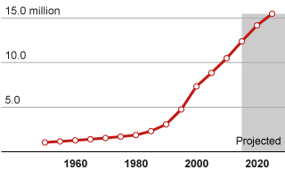
Guangzhou
2010 Population: 10.5 million
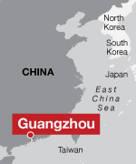
Source: World Urbanization Prospects 2011 revision from the UN
In Guangzhou, other Chicago architects are trying a different approach to humanizing Chinese housing. They want to bring a modernized fragment of the old city to the new city — in this case a massive high-rise residential complex in a tumble-down outlying district called Huadu. At its heart is a reinterpretation of the distinctive arcade houses that still enliven central Guangzhou. They’re called qi-lous.
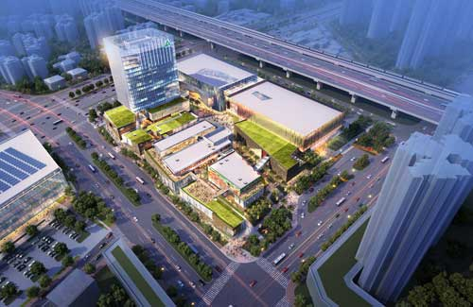
Rebuilt from traditional Cantonese houses, the qi-lous are typically three- to four-story buildings whose second floor overhangs a storefront and sidewalk. These overhangs create continuous arcades that shelter pedestrians from the tropical sun and rain. Merchants sell everything in them: shoes, men’s suits, even the side of a calf, split in half, its hoofs and tail still attached. This sort of urban grit gives the qi-lous a sense of authenticity absent from polished upscale retail complexes like the rebuilt lane houses at the heart of Shanghai’s celebrated Xintiandi district.

Now under construction, the Huadu Street Walk shopping and office complex aims to bring a modern version of Guangzhou’s traditional arcade buildings to a housing complex on the city’s outskirts. - RTKL
Better yet, the qi-lous’ architectural variety reflects Guangzhou’s historic identity as a port, open to Western influences. Some of the buildings have Gothic and Romanesque Revival facades. To walk through them is to experience architecture’s ability to shape a sense of place rather than being a series of isolated objects. This kind of architecture acquires new layers — and grows richer — over time.
The Chicago office of the global firm RTKL is trying to bring a trace of the qi-lou to the Guangzhou development that will have more than 30 towers. The development’s name is Urban Complex City, but it seems neither urban nor complex. Now under construction, the RTKL design will leaven the area’s gigantism with a three-building retail cluster known as Huadu Street Walk.
True to its name, the project will have an outdoor promenade — a refreshing change from the ultrawide streets around its monotonous towers. Flanking the promenade will be two low-slung retail structures and a 16-story office building. Overhanging roofs and pedestrian bridges will recall the sheltering arcades of the qi-lou. The buildings, however, will be modern, with facades of colored glass, glazed brick and aluminum.
“What I wanted to do was focus on experiencing the space between the buildings rather than large open spaces that don’t have a sense of human scale,” said RTKL architect Mark Lauterbach.
There’s a certain manufactured quirkiness to all this. At best it’s likely to come off as an afterthought fix for a larger project that displays all the mistakes of typical Chinese apartment blocks. But some urbanity is better than none, and residents of the Urban Complex City said they were eagerly anticipating the new retail center.
Here, at least, urban vitality is catching up to the new housing blocks. The builders get it. “Everyone can walk here. Everyone is joined together,” Chen Yanju, a supervising engineer for Agile Property Holdings, said as he walked through the concrete skeleton of one of the buildings.
It may be too late for such innovations to transform China’s packed eastern cities. For the central portion of the country, where growth is sure to spread, other Chicago architects are designing an innovative city that could give China what it desperately needs: high-density urban living unaccompanied by overcrowded streets and polluted skies.
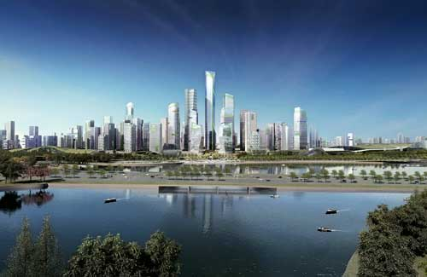
In their plan, architects Adrian Smith and Gordon Gill draw on many of the same principles that informed the Chicago Central Area DeCarbonization Plan, their award-winning blueprint for reducing the Loop’s carbon footprint by 80 percent by 2020. The most important idea is mixing where people work with where they live. If people can walk, rather than drive, to their jobs and errands, the architects reason, they’ll use less energy and produce less pollution.

A master plan for a satellite city outside the Chinese metropolis of Chengdu would break from the rigid repetition and single-use character of Chinese apartment blocks. It calls for integrating apartment buildings of varying heights with commercial high-rises, enabling people to walk anywhere in the city in about 15 minutes. - Adrian Smith + Gordon Gill Architecture

The plan is for a satellite city about 15 miles from downtown Chengdu, a metropolis in south-central China. The satellite city would rise near a planned government center, lessening the potential for sprawl. Its curving core area would contain office buildings, apartment towers and museums along a park. About 100,000 people would live there. You could walk from one end of the city to another in about 15 minutes.
“The idea is to provide a live-and-work environment,” Smith said. “It’s designed for middle-income Chinese who can’t afford a car.”
He and Gill have paid particular attention to living conditions. They rejected the usual mass of apartment towers, all about 30 stories high. Instead, the architects call for towers that would step gradually upward to an iconic skyscraper. Low-rise courtyard housing would frame small, London-style parks and give the area a variety of scales — a welcome shift from the monotony of look-alike towers. They also reduced road widths, based on the idea that most people would walk to work.
It remains to be seen whether the plan is ever built, particularly in light of the changes that undercut Perkins+Will’s vision for the Class Dream complex.
“There’s a lot of hope there,” Smith said, “but you’re dealing with Chinese developers who have to execute these plans. We don’t have any control over it.”
Still, the plan offers a promising model for China’s rapid growth and the high-rise housing that forms one of its most inglorious byproducts. It does what architects and urban planners do best, offering a granular vision for China’s broad-brush goal of “human-centered” urbanization. It’s not an object striving to be noticed. It’s a well-thought-out response, both humanistic and technological, to one of the most pressing issues China faces today: how architecture shapes the way we live.
Take notes on the following as you read… you will then have a free response question to answer based on the reading the last 25 minutes of class tomorrow. You will be able to use your article to answer the question.
Population Growth
Housing Needs
Housing Quality/ Type
Chinese Modern Lifestyles
Chicago Connection
Concerns for future

