**“To What Extent Is American Culture Similar to the Culture of the Country of your Choice?”**

**During this Introduction to Geography Project you will:**

* Become familiar with the Seven Elements of Culture
* Compare and contrast the United States and another country
* Research culture using a library database
* Format your research in a 13-15 sentence essay
* Draw conclusions about the similarities and differences between two separate cultures

**THE SEVEN ELEMENTS OF CULTURE**

**SOCIAL ORGANIZATION**

Creates social structure by organizing its members into small units to meet basic needs.

**CUSTOMS AND TRADITIONS**

Rules of Behavior are enforced ideas of right and wrong. They can be customs, traditions, rules, or written laws.

**RELIGION**

Answers basic questions about the meaning of life.

Supports values that groups of people feel are important.

**LANGUAGE**

Language is the cornerstone of culture.

All cultures have a spoken language (even if there are no developed forms of writing).

**ARTS AND LITERATURE**

They are the products of the human imagination.

Examples: art, music, literature, and folk tales

**FORMS OF GOVERNMENT**

People form governments to provide for their common needs, keep order within society, and protect their society from outside threats.

**ECONOMIC SYSTEMS**

How people use limited resources to satisfy their wants and needs…Answers the basic questions: what to produce, how to produce it, and for whom.

Over the course of this school year we will study many cultures. It is important for us to have a firm understanding of the Seven Elements of Culture. We will research one or two elements of culture and compare and contrast those 1-2 elements using two countries [The United States and a country of your choice other than Canada or Mexico] You will use online databases to find information, compare and contrast, and lastly write a 13-15 sentence essay. We will have class time to work on this project and checkpoints along the way to monitor progress.

**PARTS OF THE PROJECT**

**Part 1: RESEARCH to answer the question: “To What Extent Is American**

**Culture Similar to the Culture of the Country of your Choice?”**

* Bulleted list of facts about each country [The United States and your

selected country]

* Summarize information in your own words
* All information will need to be cited

**Part 2: Construct a Claim Statement**

* Using a sentence starter (from the Sentence Frames handout) or a claim of

your own making, answer the question: **“To What Extent Is American**

**Culture Similar to the Culture of the Country of your Choice?”**

**Part 3: Prove your Claim Statement in a 13-15 sentence paragraph**

* Focus your compare/contrast on the 1-2 elements of culture of each country

that you chose

* Synthesize the facts from your research (Do not just restate)
* Use words: like, similar to, also, unlike, similarly, in the same way,

Likewise, again, on the contrary, despite, on the other hand, etc.

* Don’t just laundry list facts, make sure to PROVE your claim
* Use in-text citations when noting facts that are not common knowledge

**Construct a Conclusion**

* Restate the claim statement
* Make a broad statement about why people should study culture
* Do not end the essay with a question!

**TASK LIST**

**TASK #1**: Select **ONE to TWO** elements of the seven elements of culture to research. Circle it/them on page 1 of this handout.

**TASK #2**: Select a country to compare on Ms. Wilda’s worksheet and contrast it with the United States. Write the country name here-

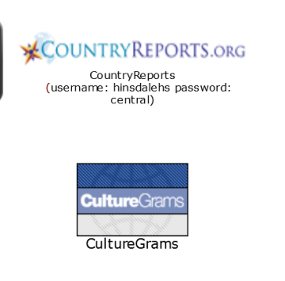_______________________________________________

**TASK #3**: Go to the Hinsdale Central Library Webpage and to “Search Databases.” Use either *CountryReports* or *CultureGrams*. Explore the database and become familiar with the tabs on the left. Click and see what types of information exists on each database.

**TASK #4**: RESEARCH. Compile research in your notes sheet. Be sure you are summarizing, not copying and pasting! ***Using word for word information from databases is considered plagiarism.***

**TASK #5**: Save the citations from *CultureGrams* by clicking on “Generate Citation” and “MLA.” (You need a minimum of two citations on your MLA Works Cited Page).

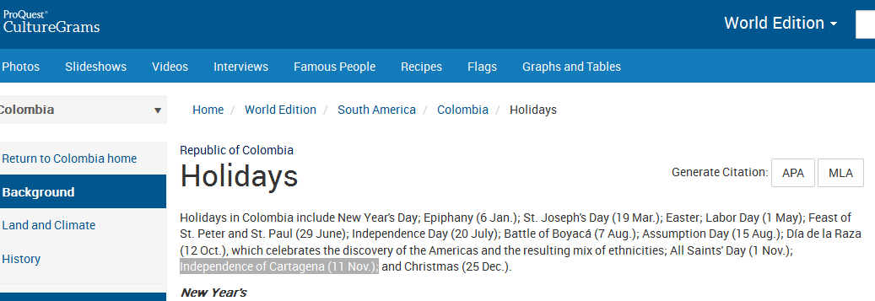



For *CountryReports*, click on “Internet Citation” at the bottom of the page and replace the first “CountryReports” with the name of your country. For example:

"Mexico" CountryReports. CountryReports, 2015. Web 31 Aug. 2015.

**TASK #6:** Create an MLA Works Cited Page, following the guidelines from class.

**TASK #7:** Construct a solid rough draft essay with the elements necessary, according to the example essay and the grading rubric.

**TASK #8:** Make revisions to your essay and complete the final draft with your MLA Works Cited Page.

**CHECKPOINTS**

* **Checkpoint #1: Due at the end of Thursday, September 10, 2015**
* Tasks 1- 3 are complete [Select one element of culture to compare/contrast, select comparison country and explore databases]
* **Checkpoint #2: Due at the end of Friday, September 11, 2015**
* Task 4-6 are to be completed. Notes need to be written in your notes sheet. Citations should be catalogued in your MLA Works Cited Page.
* **Checkpoint #3: Due at the beginning of class on Monday, September 14, 2015**
* Task 7: Rough Draft of the Essay with the MLA Works Cited Page.
* **Checkpoint #4: Due at the beginning of class on Tuesday, September 15, 2015**
* Task 8: Final Draft of the Essay with the MLA Works Cited Page is due at the beginning of class on Tuesday, 9/15.

**“To What Extent Is American Culture Similar to the Culture of the Country of your Choice?”**

**PROJECT DUE ____________________________**

**If you are absent, you MUST email me your essay by the time your class period starts on the day it is due!\*\***

**(If you do not turn in the essay on the day and time it is due, you will earn a late grade!)**