Calculate your Carbon Footprint
A carbon footprint is a "measure of the impact human activities have on the environment in terms of the amount of greenhouse gases produced, measured in units of carbon dioxide".
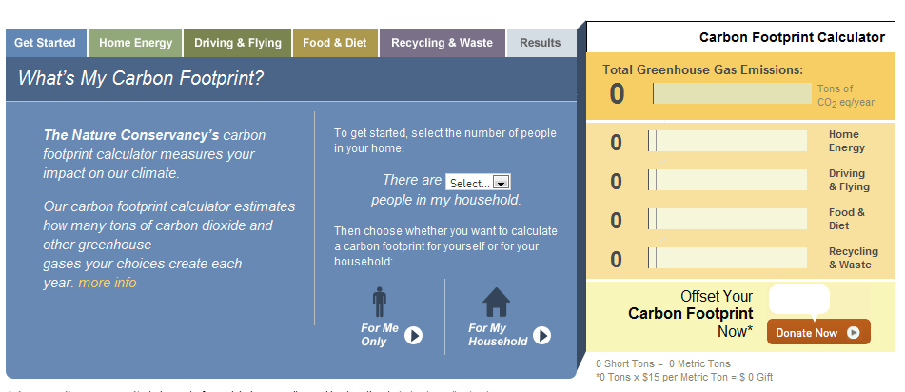
- Go to http://www.nature.org/greenliving/carboncalculator/index.htm via sharepoint
- Calculate your household’s carbon footprint (everyone in your family)
- Write down your results below (they will appear in the boxes to the right.

Short Answer----I would like you to select TWO ways that YOU can reduce your carbon footprint.
Write what you will do and how you will do it. This should be about 5-7 sentences.

