Arab Spring: What’s Next?
INSTRUCTIONS: Star every vocabulary word you knew, check mark next to ones you somewhat know and question mark next to words that are new or unfamiliar to you.
Vocabulary:
Ousting (oust): to expel/remove from a place or position occupied.
Spurred (spur): anything that urges/impels, as to action, speed, or achievement.
Upheaval: strong or violent change or disturbance.
Reform: the improvement or amendment or something that is wrong, corrupt, or unsatisfactory.
Complicity: being an accomplice; partnership or involvement in wrongdoing (as in a crime).
Spectacle: a public show or display
Regime: a government in power
Ally: a nation that is associated with another for a common cause or purpose
Hostile: not friendly, warm or generous. Not hospitable.
Deposed (depose): to remove from an office or position (especially one that is powerful)
Radicals: a person who holds extreme beliefs or principles, an extremist
Hijacking (hijack): to engage in stealing or seizing

MARKING THE TEXT:
- Underline key ideas, circle key terms that help address the question: Why did people in the Middle East protest during the Arab Spring and where were the effects?

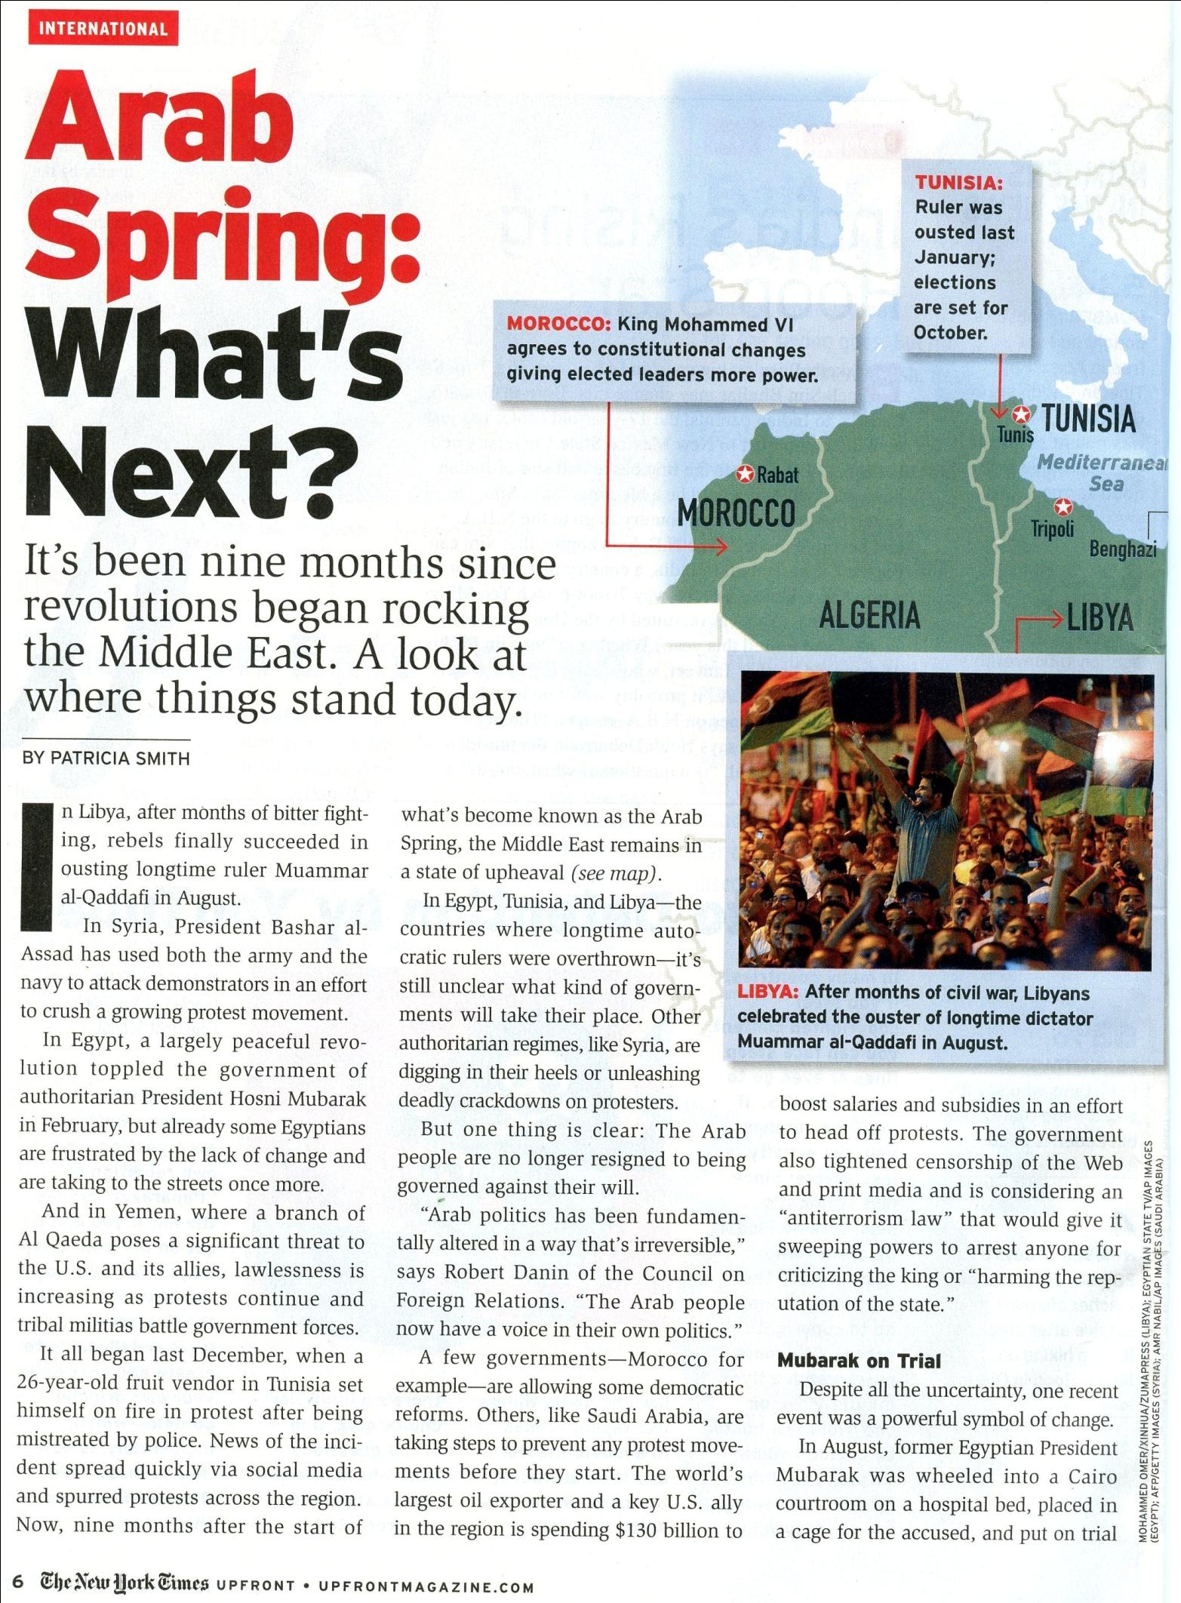
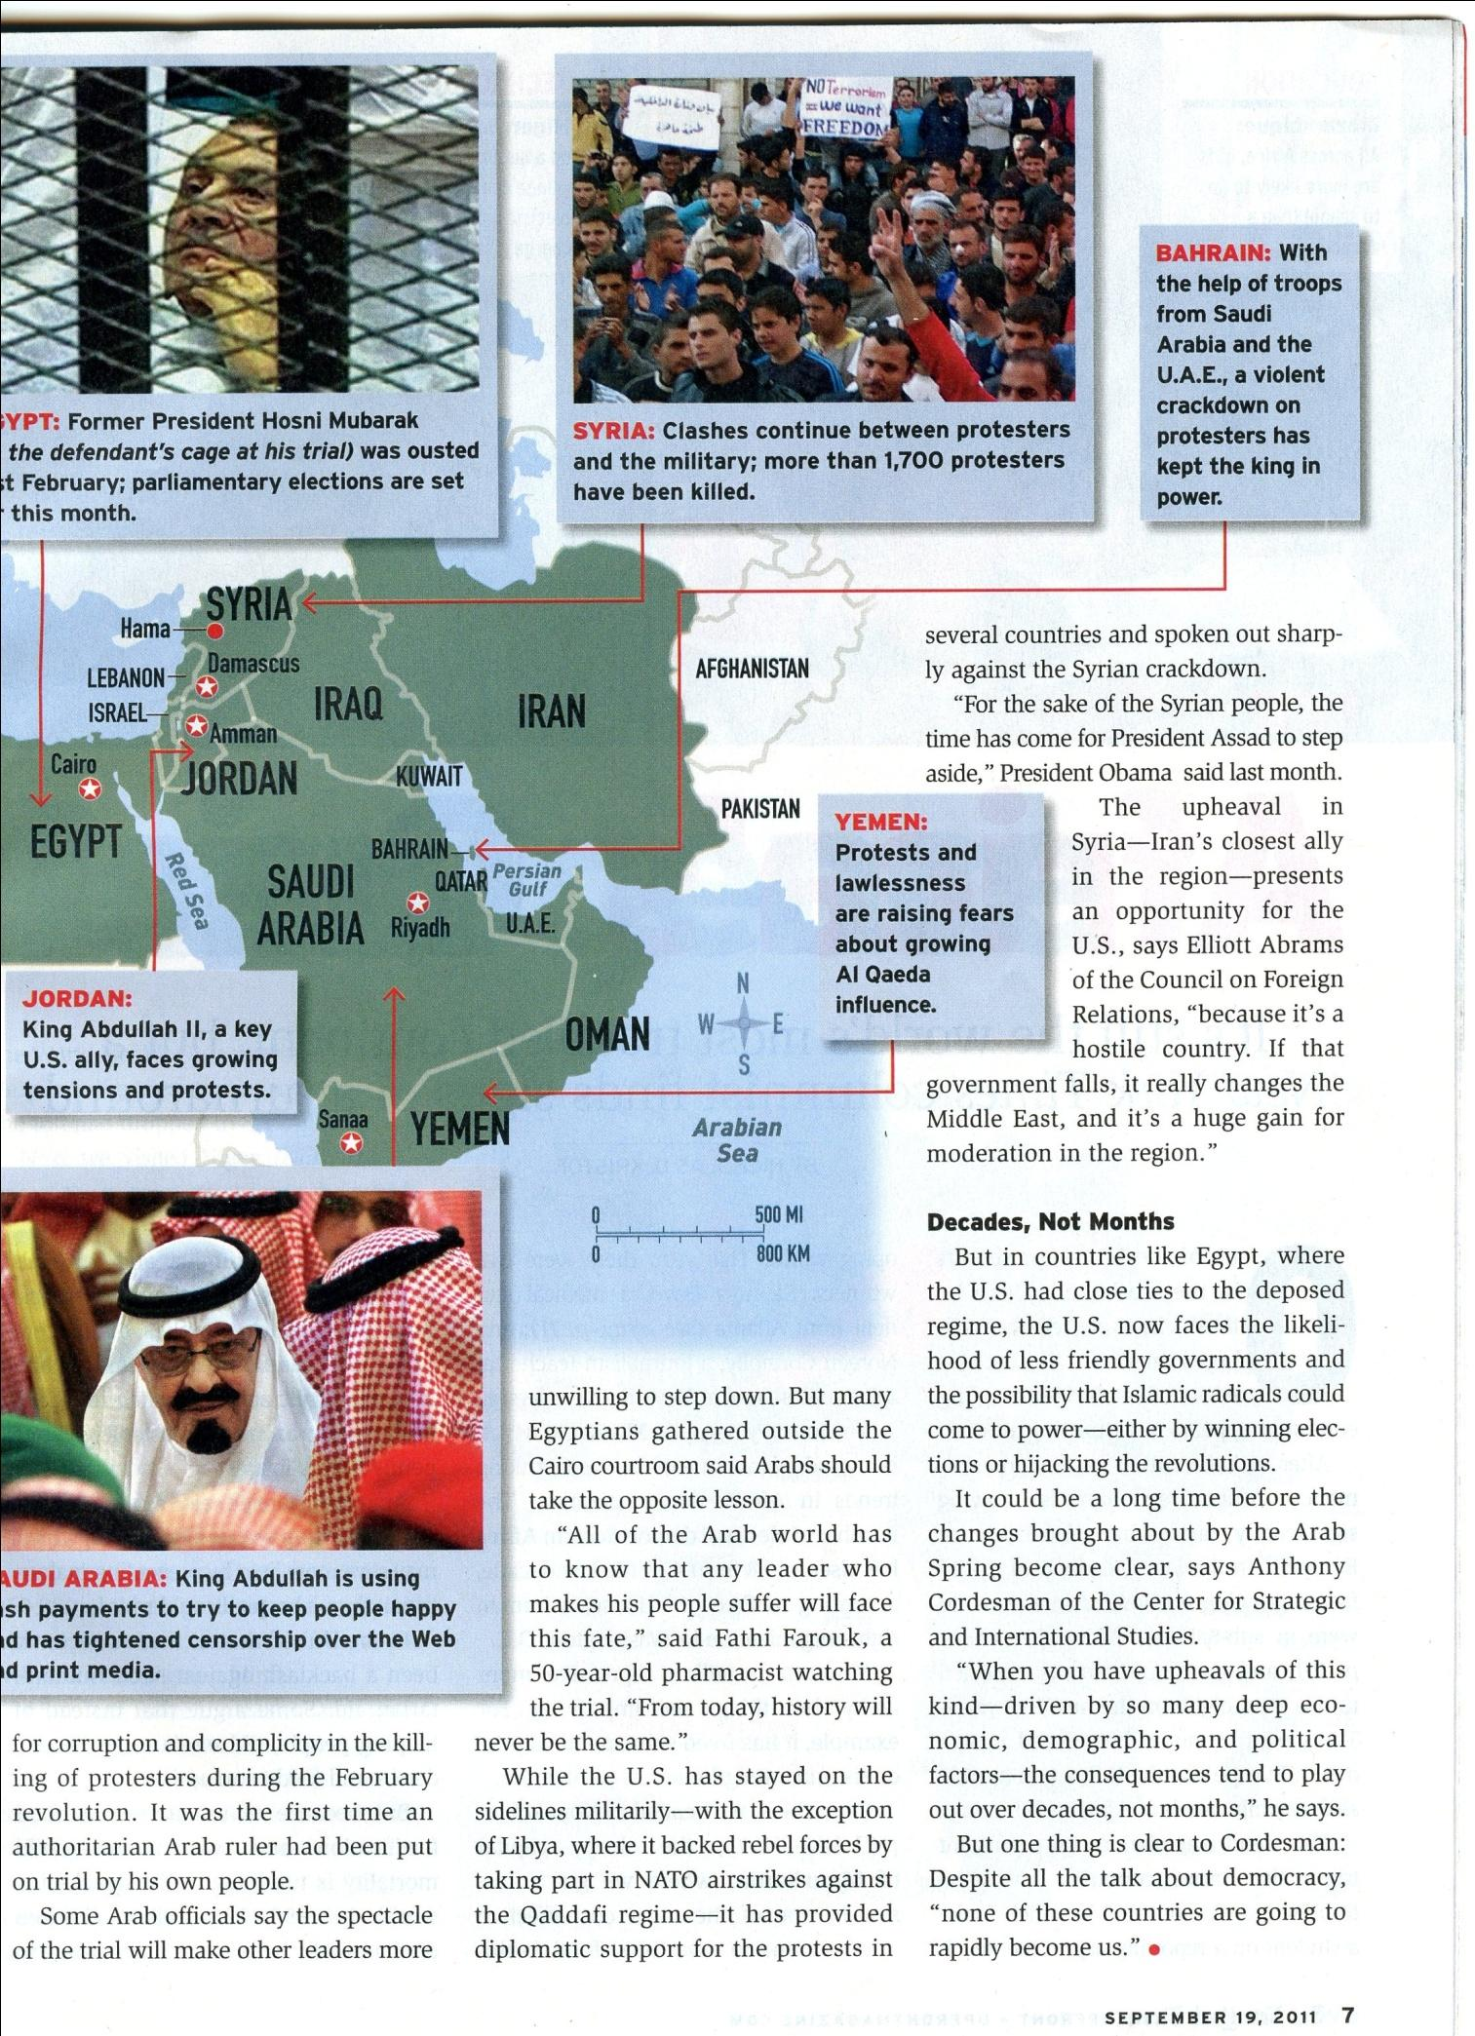
Arab Spring: What’s Next?
The New York Times Up Front September 19, 2011
After reading the article, answer the following questions.
- Recent uprising have led to the fall of the autocratic rulers in ___________________.
- Syria and Yemen
- Saudi Arabia
- Libya and Saudi Arabia
- Egypt, Tunisia and Libya

- The government of Morocco has reacted to nearby uprisings by
- Having the army attack protesters
- allowing some democratic reforms
- Putting parliamentary elections on hold
- Putting rebels on trial

- Egyptian leader_______________ was put on trial by his own people.
- Hosni Mubarak
- Bashar al- Assad
- Muammar el- Qaddafi
- King Abdullah
- The U.S and its allies have conducted air strikes to help topple the government in __________.
- Syria
- Yemen
- Tunisia
- Libya
- Saudi Arabia is considering a law that would allow the government to arrest people for ______________.
- Using the internet
- Criticizing the King
- Earning high salaries
- Exporting oil
Write a summary of the article by filling in the blanks below. To help identify the author’s argument, decide what the keywords of the article were and then show the relationship between those keywords.
KEY WORDS: _________________________________________________________________________________
SUMMARY: In this _____article_________ (editorial/speech/video/article, etc.), (author) ____ Patricia Smith____ argues that _________________________________________________________________________________.
___________________________________________________________ One key idea that supports this argument is ___________________________________________________________________________________________________________________
_____________________________________________________________________________________________________________________
Another key idea that supports this argument is __________________________________________________________
_____________________________________________________________________________________________________________________
A final key idea that supports this argument is ____________________________________________________
_______________________________________________________________________________________________________. These ideas are connected to _______________________________________________________________________________
(something you learned or experienced previously) because _________________________________
_____________________________________________________________________________________________________________________
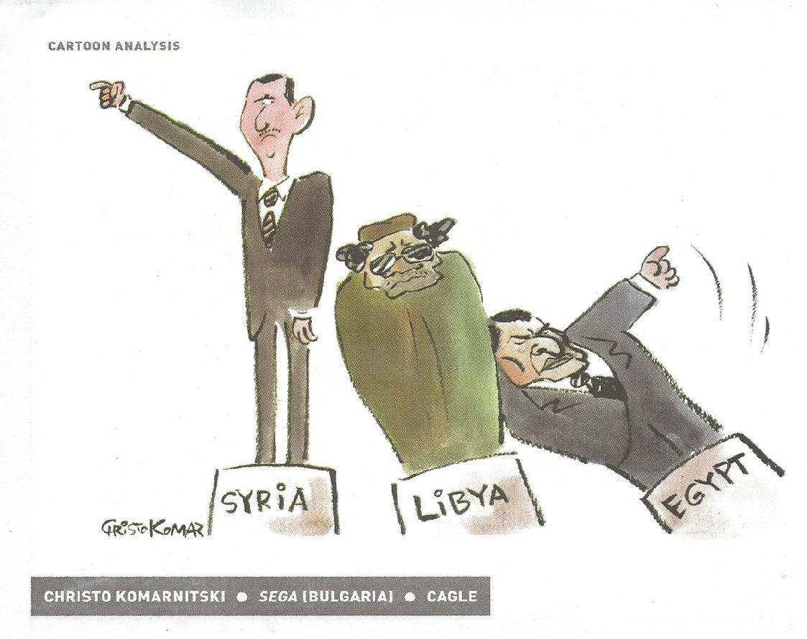
Thinking about the reading and what is going on in the Middle East today. Analyze what is going on in this cartoon.
Write your answers to the questions below . Be ready to justify your answers.
- Who do the three figures in the cartoon represent?

- Why are the figures falling like dominoes?

- What prediction does the cartoonist seem to be making about Syria?

- Do you think the Middle East revolutions will make the region more U.S. friendly? Explain.

