Applying Ethnocentrism & Cultural Relativism to Images & Clips

Directions: Using the terms discussed in class, apply them to the images and clips below.

Image | Describe what you see in the image/clip. | Ethnocentric View | Cultural Relativism View
#1 | Ex.  - Three women sitting on the floor.  - One is pouring tea.  - They are dressed up and have their hair and makeup done. | Ex. The makeup doesn’t match their skin tone and having tea on the floor is on odd practice. Why wouldn’t they use a table? It would be much easier. | Ex. This is a geisha tea ceremony practice that is now part of a dying culture in Japan. They paint their faces white because original geishas only had candle light to show their faces at night and needed their facial expressions to be seen so they used a mixture of rice powder and water to give a porcelain look.
#2 (China)
#3 (Greenland)
#4 (India)
#5 (Bahrain)
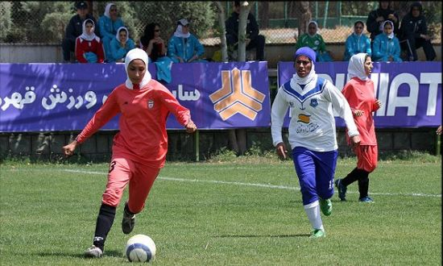
#6

What happens when kids try lunches from around the world?

#7

basketball New Zealand (Maori) & USA

