Africa Map: **Political Map** Name: _________________________________

[Algeria](http://www.africaguide.com/country/algeria/)

[Angola](http://www.africaguide.com/country/angola/)

[Benin](http://www.africaguide.com/country/benin/)

[Botswana](http://www.africaguide.com/country/botswana/)

[Burkina Faso](http://www.africaguide.com/country/bfasso/)

[Burundi](http://www.africaguide.com/country/burundi/)

[Cameroon](http://www.africaguide.com/country/cameroon/)

[Cape Verde](http://www.africaguide.com/country/cverde/)

[Central African Rep](http://www.africaguide.com/country/car/)

[Chad](http://www.africaguide.com/country/chad/)

Comoros

Congo (Brazzaville)

Congo (DRC, Zaire)

[Cot](http://www.africaguide.com/country/ivoryc/)e d’Ivoire

[Dem. Rep. Congo )](http://www.africaguide.com/country/zaire/)

[Djibouti](http://www.africaguide.com/country/djibouti/)

[Egypt](http://www.africaguide.com/country/egypt/)

[Equatorial Guinea](http://www.africaguide.com/country/eguinea/)

[Eritrea](http://www.africaguide.com/country/eritrea/)

[Ethiopia](http://www.africaguide.com/country/ethiopia/)

[Gabon](http://www.africaguide.com/country/gabon/)

[Gambia](http://www.africaguide.com/country/gambia/)

[Ghana](http://www.africaguide.com/country/ghana/)

[Guinea Bissau](http://www.africaguide.com/country/guineab/)

[Guinea](http://www.africaguide.com/country/guinea/)

[Kenya](http://www.africaguide.com/country/kenya/)

[Lesotho](http://www.africaguide.com/country/lesotho/)

[Liberia](http://www.africaguide.com/country/liberia/)

[Libya](http://www.africaguide.com/country/libya/)

[Madagascar](http://www.africaguide.com/country/madagas/)

[Malawi](http://www.africaguide.com/country/malawi/)

[Mali](http://www.africaguide.com/country/mali/)

[Mauritania](http://www.africaguide.com/country/mauritan/)

[Mauritius](http://www.africaguide.com/country/mauritis/)

[Morocco](http://www.africaguide.com/country/morocco/)

[Mozambique](http://www.africaguide.com/country/mozamb/)

[Namibia](http://www.africaguide.com/country/namibia/)

[Niger](http://www.africaguide.com/country/niger/)

[Nigeria](http://www.africaguide.com/country/nigeria/)

Reunion

[Rwanda](http://www.africaguide.com/country/rwanda/)

Sao Tome and Principe

[Senegal](http://www.africaguide.com/country/senegal/)

[Seychelles](http://www.africaguide.com/country/seychel/)

[Sierra Leone](http://www.africaguide.com/country/sleone/)

[Somalia](http://www.africaguide.com/country/somalia/)

[South Africa](http://www.africaguide.com/country/safrica/)

[Sudan](http://www.africaguide.com/country/sudan/)

[Swaziland](http://www.africaguide.com/country/swazi/)

[Tanzania](http://www.africaguide.com/country/tanzania/)

[Togo](http://www.africaguide.com/country/togo/)

[Tunisia](http://www.africaguide.com/country/tunisia/)

[Uganda](http://www.africaguide.com/country/uganda/)

Western Sahara

[Zambia](http://www.africaguide.com/country/zambia/)

[Zimbabwe](http://www.africaguide.com/country/zimbab/)

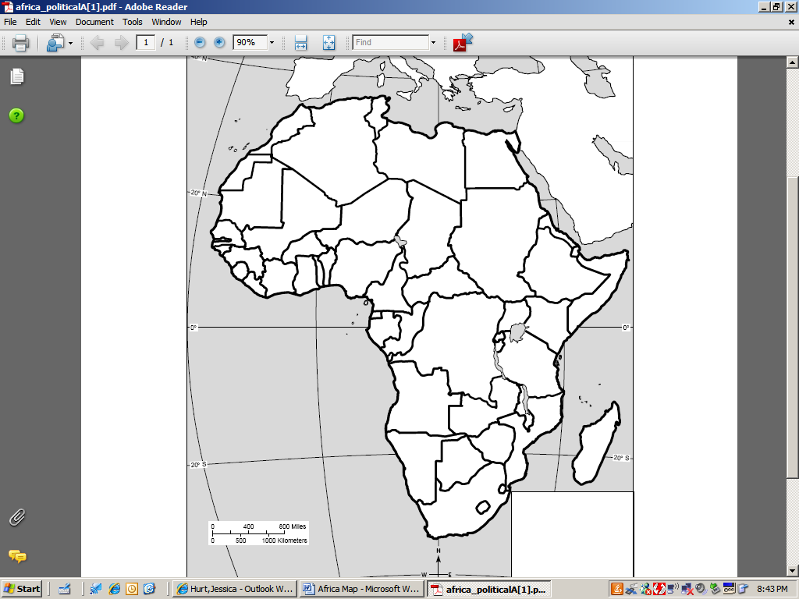

Map Quiz Monday!

Drag and drop Africa quiz link on our website!!!

**Africa: Physical Map**

Sahara Desert

Kalahari Dessert

Mt. Kilimanjaro

Atlas Mountains

Nile River

Congo River

Drakensberg Mountains

Namib Desert

Lake Victoria

Lake Tana

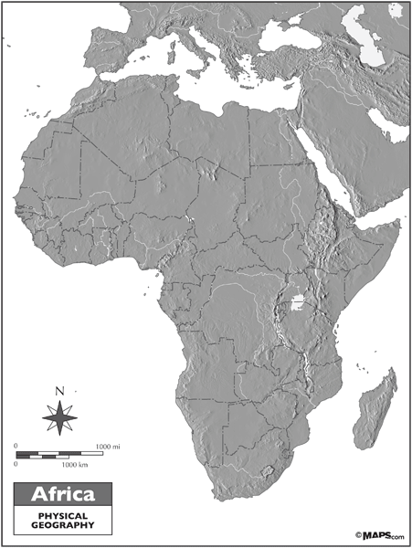

Label and color all physical features.