Name:______________________________________________________Date: _____________Period: _______________
LITERACY GUIDE – AFRICA
Textbook Chapters you will use: Chapter 3 Section 1 & Section 2 (pages 59-71) Chapter 4 Section 2- 4 (pages 85-101) Chapter 5 Section 1 (107-11) Chapter 6 Section 2 (pages 139-142)

FOCUS QUESTIONS:
- I will be able to identify the physical and political features of Africa.
- I will be able to describe the impact Africa’s diverse climate on its people.
- I will be able to analyze the effects of European Imperialism on traditional African societies (African culture, slave trade, apartheid).

PRE-READING:
- PREDICT: How have landforms influenced movement across Africa?

- PREDICT: What ways of life did Africans develop? What had the greatest impact on that development?

- PREDICT: Why did Europeans become interested in Africa?

VOCABULARY: Fill in the chart (identify)
Vocabulary Term | Definition (In your own words) | Illustration / Example
Chapter 2 Section 1 The Shape of the Land pages 59 - 64
Escarpment

Cataracts

Hydroelectric Power

Chapter 3 Section 2 Climate & Diversity pages 64 - 71
Tropics

Leaching

Savanna | Grasslands that cover almost ½ of Africa.  Found in wet & dry tropical climate zones.
Drought

Desertification

Chapter 4 Section 2 Patterns of Life pages 85 - 92
Lineage

Clan | Social organization in Africa. Clans were made up of several lineages that shared duties & obligations to one another.
Consensus

Subsistence Farming

Bride Wealth

Age Grade

Chapter 4 Section 3 The Slave Trade pages 93 - 96
Middle Passage

Abolition

Diaspora

Chapter 4 Section 4 Age of Imperialism pages 97 - 101
Imperialism

Chapter 5 Section 1 Winning Independence pages 107 - 111
Nationalism

Boycott

Chapter 6 Section 2 The Republic of South Africa pages 139 - 142
Apartheid

APPLICATION: Use the picture below and apply your knowledge of HEI (human environment interaction) to explain the relationship between the people and the Nile River. Dig Deep and make as many connections as you can. Write your answer in the box provided.
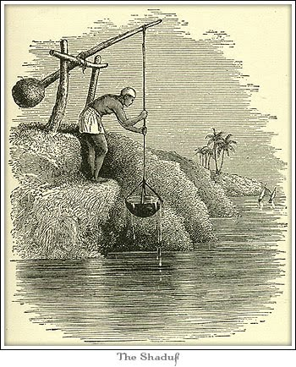
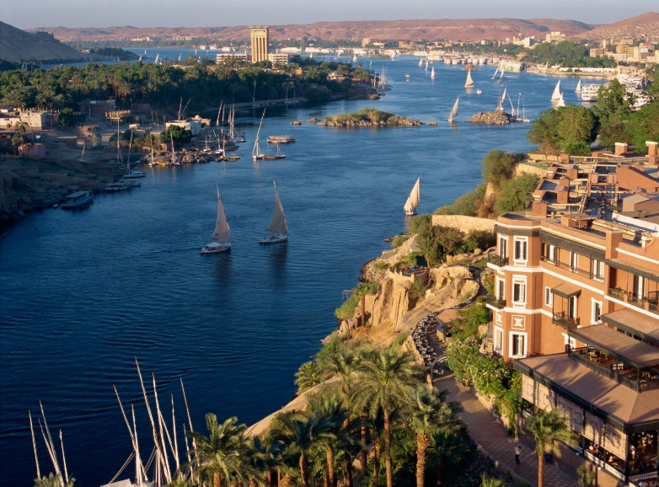

ADAPT, DEPEND, CHANGE

Note Taking: Mind Maps & Climate Chart Chapter 1 Section 1 [pages 59 – 63]
In the blanks – identify each region. For the boxed words create a mental map from the reading.

Nile River

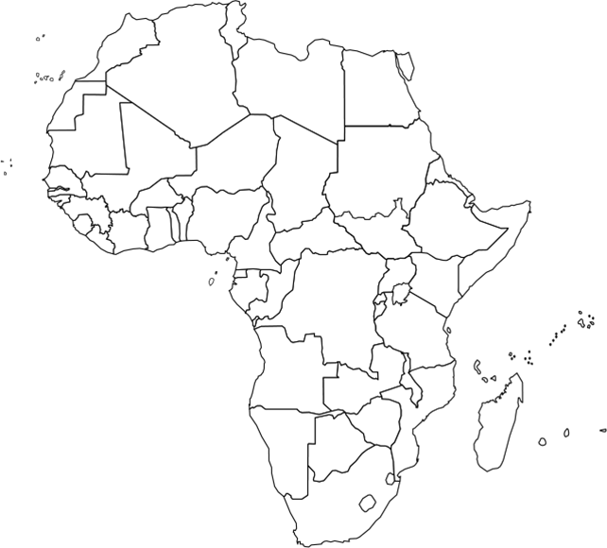
Niger River
Aswan Dam

Great Rift Valley
Congo River

Chapter 1 Section 2 [pages 64-71]
1. Using pg. 65, color the map for the 4 major climate regions. Create a key with the title boxes below.
2. Fill in chart: Read the section and take notes over each climate region. Give an example of how people interact with the environment in each region.

Tropical Wet | Tropical Wet & Dry | Desert | Mediterranean
Adapting to the Land: examples of HEI (depend, adapt, change)

ASWAN HIGH DAM
Encyclopædia Britannica
Aswan High Dam, a rock filled dam across the Nile River, at Aswān, Egypt, completed in 1970 at a cost of about $1 billion. The dam, 364 feet high, with a crest length of 12,562 feet and a volume of 57,940,000 cubic yards, impounds a reservoir, Lake Nasser, that has a gross capacity of 5.97 trillion cubic feet. Of the Nile’s total annual discharge, some 2.6 trillion cubic feet of water have been allocated by treaty between Egypt and Sudan, with about 1.96 trillion cubic feet apportioned to Egypt and the remainder to Sudan. Lake Nasser backs up the Nile about 200 miles in Egypt and almost 100 miles farther upstream (south) in Sudan; creation of the reservoir necessitated the costly relocation of the ancient Egyptian temple complex of Abu Simbel, which would otherwise have been submerged. Ninety thousand Egyptian fellahin (peasants) and Sudanese Nubian nomads had to be relocated. Fifty thousand Egyptians were transported to the Kawm Umbū valley, 30 miles north of Aswān, to form a new agricultural zone called Nubaria, and most of the Sudanese were resettled around Khashm al-Qirbah, Sudan.
The Aswan High Dam yields enormous benefits to the economy of Egypt. For the first time in history, the annual Nile flood can be controlled by man. The dam impounds the floodwaters, releasing them when needed to maximize their utility on irrigated land, to water hundreds of thousands of new acres, to improve navigation both above and below Aswān, and to generate enormous amounts of electric power (the dam’s 12 turbines can generate 10 billion kilowatt-hours annually). The reservoir, which has a depth of 300 feet and averages 14 miles in width, supports a fishing industry.
The Aswan High Dam has produced several negative side effects, however, chief of which is a gradual decrease in the fertility and hence the productivity of Egypt’s riverside agricultural lands. This is because of the dam’s complete control of the Nile’s annual flooding. Much of the flood and its load of rich fertilizing silt is now impounded in reservoirs and canals; the silt is thus no longer deposited by the Nile’s rising waters on farmlands. Egypt’s annual application of about 1 million tons of artificial fertilizers is an inadequate substitute for the 40 million tons of silt formerly deposited annually by the Nile flood.
PRO evidence | Depend, Adapt, Change | CON evidence | Depend, Adapt, Change
1. |  | 1.
2. |  | 2.
3. |  | 3.

Claim/Thesis Statement
______________________________________________________________________________________________________________________________________________________________________________________________________________________________________________________________________________________________________________________________________________________________________________________________________________________________________________________________________________________________________________________________________________________________________________________________________________________________________________________________________________________________________________
TRANSFERENCE: Find the picture, graph, or map on the identified pages, read and analyze the information and answer the question(s).

APPLICATION Page 67: ENVIRONMENT Why is unpredictable rainfall a serious concern for all life in the savanna?

APPLICATION Page 68: ENVIRONMENT How does technology change the ways people adapt to their environment?

APPLICATION Page 70: CULTURE How does trade promote cultural diffusion?

PARAPHRASING YOUR IDEAS: Using complete sentences, students should paraphrase the excerpts from the text.
Excerpt from text | Paraphrase
“In farming and herding societies, people were more likely to live in extended families. In a farming village, several families pooled their labor. They worked together on such as clearing land, building homes and harvesting crops, which demanded a large labor force.”

“Several lineages formed a clan, which traced its roots to an even earlier ancestor. Members of a clan also shared duties and obligations toward one another. Each clan had its own leaders who made important decisions for the community.”

“Giving bride wealth was a way of recognizing a women’s importance. At the time of marriage, the bride’s family lost its daughter’s valuable labor. By giving bride wealth, a mean was honoring the bride’s family. By accepting the bride wealth, a woman’s family acknowledged the bond that marriage created.”

“Many African’s believed that their ancestors could help or harm them. To honor and please their ancestors, people said prayers and performed certain rituals. Often, the clan leader was responsible for these ceremonies.”
NOTE TAKING – CORNELL NOTES: After you have read pages 85 – 92, complete the Cornell Notes.

TOPIC: Patterns of Life
QUESTIONS: NOTES:
Family Ties
1.

2.

Government
- Organization:

- Consensus:

Economic Organization
- Farming
Subsistence farming

Women
- Roles/Status

- Bride Wealth

Age Grade:

African Religions:

- Traditional

- Diviners & Healers

- Christianity, Judaism & Islam

Summary:

